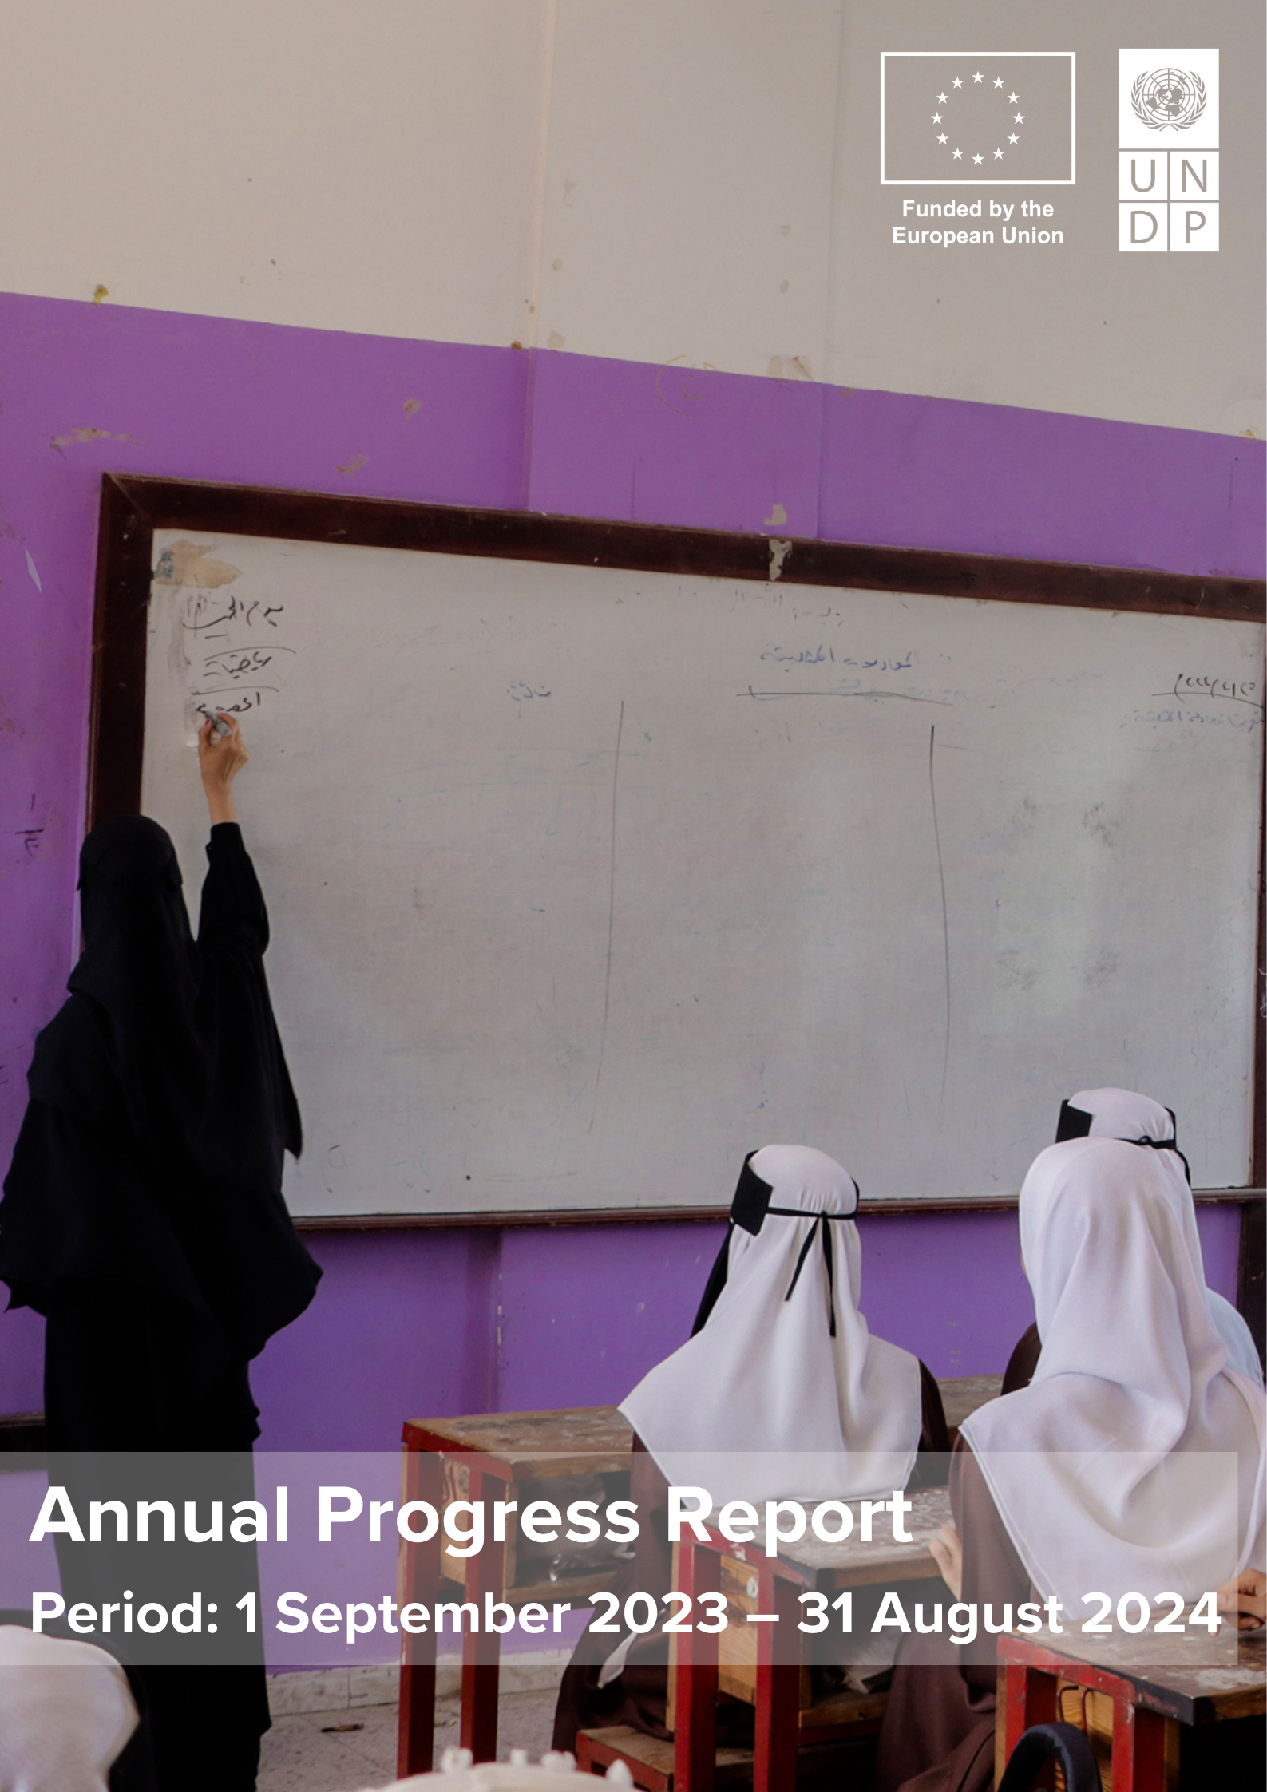

Contents

ACRONYMS 3
Project Information 4
I. EXECUTIVE SUMMARY 5
II. BACKGROUND 7
III. PROGRESS TOWARD PROJECT IMPACT, OUTCOMES AND OUTPUTS 10
3.1 Progress toward project impact 10
3.2 Progress toward project outcomes 11
3.3 Progress toward project outputs 13
3.4 Changes introduced during the reporting period 41
3.5 Factors affecting the attainment of results and mitigation measures 42
3.6 Communication and Visibility 44
IV.CROSS-CUTTING ISSUES 48
4.1 Gender results 48
4.2 Partnership 48
4.3 Environmental Consideration 49
V. LESSONS LEARNED 49
VI. WAY FORWARD 51
List of Annexes 53
Annex II: Implementation Plan 54
Annex IV Timeline of Activities 60

ACRONYMS

ABC Agri-Business Center
BAs Business Advisors
BARC Business Advisory Resource Centre
BCAs Business Cooperative Associations
BoQs Bills of Quantities
CS Community Structure
CoC Chambers of Commerce
CP4LER Collaborative Platforms for Local Economic Recovery
CSOs Civil Society Organizations
DCDP District Capacity Development Plan
DCT District Core Team
DEO District Education Office
DFA De Facto Authority
DRP District Resilience Platform
D2RP District Resilience & Recovery Plan
DFT District Facilitation Team
FGD Focus Group Discussions
FSS First Stop Shops
IDP Internally Displaced People
IFC International Finance Cooperation
IRG International Recognized Government of Yemen
LA Local Authority
LED Local Economic Development
LER Local Economic Recovery
L2RF Local Resilience and Recovery Fund
MoPIC Minister of Planning and International Cooperation
MoLA Ministry of Local Administration
MFIs Microfinance Institutions
NGOs Non-governmental Organizations
OHS Occupational Health Safety
OSS One-Stop Shops
PEM Public Expenditure Management
RP Responsible Party
SCMCHA Supreme Council for the Management and Coordination of Humanitarian Affairs
SDG Sustainable Development Goal
SES Social & Environmental Screening
SMEs Small & Medium Enterprises
TPMA Third-Party Monitoring Agent
UN United Nations
UNDP United Nations Development Programme
UPMT Urban Planning and Management Team

Project Information

Country | Yemen
Donor | European Union
Project title: | Strengthening Institutional and Economic Resilience in Yemen (SIERY)
EU Contribution Agreement: | MIDEAST/2020/416-174
UNDP Project ID | 00122248 / 00131456
Impact | To ensure economic and social wellbeing for Yemeni, in particular for the poorest and most vulnerable
Outcomes | OUTCOME 1 -Increased institutional and socio-economic resilience in targeted districts in Yemen  OUTCOME 2 -Improved business environment for economic recovery and employment opportunities
Outputs | Output 1.1: Strengthened Local authorities’ capacities to respond to community needs for services in an inclusive and accountable manner.  Output 1.2: Improved capacities of public services providers for scaling up the reach out to the most vulnerable.  Output 1.3: Strengthened central-local and horizontal relations between local governance stakeholders.  Output 2.1: Strengthened linkages/cooperation opportunities between smallholders, SMEs, private sector and MFIs involved in the value chains.  Output 2.2.: Increased and de-risked access to financial services for economic agents in promising value chains.
Target governorates | Aden, Hodeidah, Hadramout, Hajjah, Ibb, Lahj, Marib, Sana’a, Taiz
Project Start Date | 19 August 2020
Project End Date | 18 August 2025
Total Budget | EUR 69,800,000.00 estimated at US$ 81,966,140.00
Total delivery (expenditures & commitments) | $57,083,914.86
UNDP Contacts Person | Zena Ali Ahmad  Resident Representative  UNDP Yemen  zena.ali-ahmad@undp.org  Maarten van Driel  Chief Technical Advisor – SIERY Project  maarten.vandriel@undp.org
Responsible Parties (RPs) | 1) Abs Development Organization for Women and Child (ADO), 2) Benevolence Coalition for Humanitarian Relief (BCHR), 3) Generation without Qat (GWQ), 4) Life Makers Meeting Place Organization (LMMPO), 5) Nahda Makers Organization (NMO), 6) National Foundation for Development and Humanitarian Response (NFDHR), 7) Public Works Project (PWP), 8) The Small and Micro Enterprise Promotion Service (SMEPS), 9) SOUL for Development, 10) Tamdeen Youth Foundation (TYF), 11) Yemen Aid, 12) Building Foundation for Development (BFD), 13) Resonate! Yemen, 14) Responsiveness for Relief and Development Foundation (RRD), 14) Qhadaq for Development.

I. EXECUTIVE SUMMARY

Support by the European Union, UNDP Yemen is successfully implementing the Strengthening Institutional and Economic Resilience in Yemen (SIERY) Project. Over the last 12 months, UNDP Yemen has successfully executed activities aligned with the Description of Action and the Project’s objectives, achieving significant outputs. This report presents a detailed overview of project achievements, challenges faced, and lessons learned for the period 1 September 2023 to 31 August 2024 and a summary financial status as per 31 August 2024.

Under the Institutional Resilience component, the Project has continued to strengthen local authorities’ institutional and individual capacities to respond to citizens’ public service needs in an inclusive and accountable manner. The localization of human resource development has been further anchored and expanded in a local capacity development structure, consisting of a network of local training providers, local authorities, and local stakeholders. The collaboration between local authorities and communities has been further bolstered towards a completion of the Community Networks in 45 districts across nine governorates in Yemen.

The Project further strengthened the capacity of the District Resilience & Recovery Platforms (D2RPs). As a result of an intensive participatory process, in all 45 districts, three-year District Resilience & Recovery Plans (D2RPs) (2024-2026) were developed. The D2RPs have been approved by the local authorities, and distributed to districts, governorates, and the Ministry of Local Administration. These D2RPs remain a specific focus for SIERY’s final implementing year.

From the 2022 and 2023 districts' development plans, over 125 local priorities (31%) of an initial list of 400 were selected for funding by the local authorities. These local public service priorities range from road rehabilitation and extension or rehabilitation of water infrastructure to education and health facilities. During the reporting period, over six (6) million Yemeni (50.5% women) benefited from the rehabilitation of public service priorities. Moreover, Internally Displaced People (IDPs) have participated in the planning and priority-setting process and are significant beneficiaries of the L2RF.

In the Education sub-component, an integral – and crucial - part of local public services was completed. Training and capacity-building for local education service providers was concluded and reported in the previous year. In this report, the Project continued with a provision of school furniture to address the high demands upon requests from the local authorities.

The Project continued to embrace the participation of Civil Society Organizations (CSOs) in responsive public service provision. A total of 19 CSOs were mobilized to pilot Social Accountability Initiatives in the Internal Recognized Government of Yemen (IRG) area. The initiatives were considered a priority for the public service providers, and they gained knowledge and skills from the relevant CSOs during the process and applied what they learned. The initiatives helped increase staff attention to service improvement and helped strengthen the service providers’ relations with the general public and community members. The service providers also indicated that the initiatives have improved transparency and financial management, a crucial component towards the sustainability of SIERY, and any potential follow-up projects and programs.

The Economic Resilience component has shown significant progress during this reporting period. The Project expanded business and technical skills to over 3,000 beneficiaries (smallholders, SMEs, enterprises) for income generation and employment prospects. Almost 35.000 people are benefiting from jobs and employment prospects across the targeted governorates. The disbursement of small grants has reached 1,619 smallholders and 394 SMEs (accumulative: 2,023). Training, financial support, and technical support provided by the project have led to notable improvements in business activities. SMEs and smallholders benefit from infrastructure improvement (e.g. water provision rehabilitation, improved access due to road rehabilitation and business and employment opportunities towards maintenance of improved infrastructure), expanding production capacity, enhancing product/service diversification, and increasing working capital. Moreover, SIERY has resulted in enhanced business performance, improved financial stability, increased competitiveness, and better resilience against economic shocks.

Highly anticipated public/private infrastructure deserves a specific mention; the new Markets: the fish market in Aden; the honey market of Hadramawt valley in in Al-Qaten; the dates and onion market of Hadramawt valley in Tarim; the fish market in Mukalla; and the central coffee market in Sana’a, finally gained tremendous momentum in 2024 after extensive discussions and coordination with all concerned parties and local authorities. Most negotiations were done by end of the reporting period, with four contracts signed and construction commenced by the time this report is submitted.
This new market infrastructure is expected to attract and directly benefit around 560 Medium and large enterprises, 36,000 smallholders, 11,000 distributors and transportation companies and 7.2 million buyers and consumers in Yemen and gulf countries per year. In addition, the construction of markets will create direct jobs in these markets with estimated 400 direct employments/jobs as staff and workers in the 5 markets and 750 jobs during the construction phase.

The Project continued to strengthen collaboration between the public and private sector, with specific roles and responsibilities for each partner along the value chain. The example from the recent “value chain study and investment opportunity workshop” organized in Aden for the fish sector showcased the collaboration between the public and private sector. The Prime Minister, overseeing the Aden Free Zone, has signed a land-use/land permit document for the fish export centre site.

Gender continued featuring strongly in both components in 2024. A total of 13 women-specific priorities (women’s training centre, health, water and sanitation) were funded for L2RF 2022. In addition, 54 percent of the overall beneficiaries of the implementation of local priorities are women and girls.
In the Economic Resilience component, the selection of the livestock and agriculture sector has enabled the Project to significantly target participation and engagement of women in economy recovery activities. This sector alone accounts for 33 percent women beneficiaries from the economy recovery activity.

With SIERY entering the final year of implementation, the project can conclude that the Institutional Component has been highly successful and is still solidifying and expanding. The Economic component (which always rode on the back of successes achieved in the Institutional component) has built a tremendous momentum and foundation that paves the way for completion of all deliverables during the last reporting period. SIERY’s achievements already now open doors for follow-up projects, both for existing as well as new donors.

The report concludes with a financial analysis of the reporting period 01.09.2023 - 31 August 2024. Key financial metrics indicate that during the reporting period, the project recorded total expenditures and legal commitments of US$ 27,669,797.75, resulting in cumulative financial delivery of US$ 57,083,914.86 against a multi-year budget of US$ 81,966,140. This reflects a robust delivery rate of 70 percent, highlighting the project's ongoing commitment to enhancing Yemen's institutional and economic resilience amidst prevailing challenges.

II. BACKGROUND
The project, “Strengthening Institutional and Economic Resilience in Yemen” (SIERY) is a comprehensive multi-year initiative designed to improve economic and social wellbeing for Yemenis, with a particular on the most vulnerable population. The overall objective is to address critical development challenges in Yemen, aligning with the European Union's Global Strategy to build resilience through good governance, strengthen the Humanitarian-Development Nexus, and promote private sector development.
SIERY is structured around two key components:
1. Institutional Resilience: This component aims to address the service delivery needs of local populations and underscores the importance of responsive, legitimate local governance in fostering peace and stability from the bottom up (specific objective 1). SIERY provides district authorities with technical support and discretionary funding to collaboratively develop and implement recovery plans with communities, the private sector, and influential local actors. These plans focus on essential service delivery and aim to enhance participatory, inclusive, and accountable governance. The initiative fosters the establishment of a nationwide compact to sustain Yemen's local governance system, thereby supporting peace and state-building efforts. In alignment with Agenda 2030, SIERY emphasizes the imperative of leaving no one behind, particularly women, children, and youth, by promoting innovative and effective strategies to address vulnerabilities across all dimensions of local governance.
2. Economic Resilience: The second component focuses on improving the business environment to facilitate economic recovery and create employment opportunities (specific objective 2). This component empowers private sector actors—primarily small and medium-sized enterprises (SMEs) and smallholders—by enhancing skills development, providing capital support, and promoting job sustainability and creation within selected value chains. SIERY is dedicated to constructing community-prioritized market infrastructure and supporting SMEs in scaling up their businesses. Additionally, it engages banks, networks, and business associations to help mitigate risks associated with the unstable market environment, thereby enabling producers and local authorities to thrive.
The SIERY project operates across 45 districts in nine (9) governorates. While institutional resilience efforts encompass all 45 districts, economic resilience initiatives are specifically targeted at 16 districts across five governorates. Through this dual approach, SIERY aims to foster a resilient, self-sustaining future for Yemen and its people.
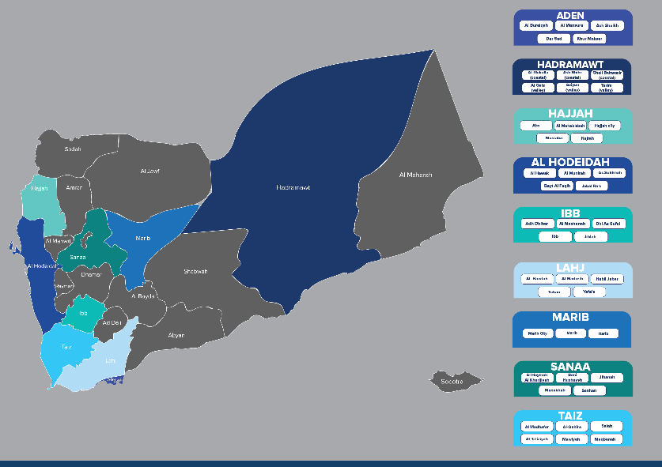

A map highlighting the governorates that the SIERY Project targets. ©UNDP
Relevant Context
The period from September 2023 to August 2024 has been one of the most volatile for the project. Regional political developments, including the war in Gaza, the situation in the Red Sea, and military actions by the United States, the United Kingdom, and Israel, have significantly impacted the Project’s implementation environment. Despite these challenges, the Project has witnessed the most substantial progress in the implementation period, including in the De Facto Authority (DFA) controlled areas, with an increase in initiatives and activities building on the project’s achievements.
Previous progress reports have highlighted how vulnerable project implementation is to fluctuations in relations between the international community and the authorities. This has been mainly with the DFA, but increasingly also with the International Recognized Government of Yemen (IRG), and in this reporting period, also at the Governorate level. In previous years, it was sometimes difficult to determine exactly how and when the authorities were reacting to these fluctuations, and impact was usually indirect, such as issuing of visas, access permissions, activity approvals, etcetera. In 2024, however, this impact was painfully clear and direct, especially in the DFA controlled areas.
The detainment of 13 United Nations (UN) staff members and numerous Non-Governmental Organization (NGO) and Civil Society Organization (CSO) staff in the DFA controlled area, along with the closure of the Office of the High Commissioner of Human Rights in Sana’a, and the subsequent information and communication campaign against the UN, has had a chilling effect on the project team, Responsible Parties, and the UN. Videos posted on social media have referred to the SIERY project as one of those attempting to influence or sabotage governance in Yemen as part of the ‘American conspiracy’. Two Responsible Parties (RPs) have been forced to close operations, while others have been called in for questioning on SIERY activities. In response to these developments, the UN Country Team Yemen has conducted a Prioritization Exercise resulting in de-prioritization of some of SIERY’s remaining activities in the DFA controlled area.
Interference by (parts of) the IRG in Aden, as noted by some other development partners, has not affected the project, due to its decentralized approach. The increasing willingness of the international community to engage more actively with sub-national authorities at the Governorate level, on the other hand, has had a positive effect on the project, not just in terms of implementation, but especially with regards to the sustainability and impact of the project’s achievements. The banking and liquidity crisis, however, (another consequence of the complex interaction between regional and national conflicts) has made a negative impact.
Yet, regardless of these new challenges, project implementation in the reporting period has significantly accelerated, benefitting from several key factors some of which are discussed more extensively in this report. Here we would like to highlight two crucial factors:
Increased Familiarity and Ownership
After 4 years, the Project has achieved a very high degree of local ownership by the local authorities (and to a lesser degree, by local businesses). They have become familiar with, and highly appreciative of, the approach adopted by the project, which rewards rigorous and responsive planning, thereby enabling cash (and central guidance) strapped local authorities to show local communities and businesses their ability and willingness to respond to their needs. Local authorities have become the project’s biggest champions in implementation, also in the DFA controlled areas, where we have witnessed pressure by the local authorities on the Supreme Council for the Management and Coordination of Humanitarian Affairs (SCMCHA) to facilitate smooth access and implementation. Local businesses appreciate the potential of the fledgling planning and collaboration mechanisms between the private and public sector the project has established.
Adaptability
Four years of implementation have also allowed the Project to adjust, finetune and leverage its set-up and approach in such a way that it has been able to absorb the many shocks a chaotic implementation environment like Yemen inevitably presents. One of the key elements of the approach has been that although the Project had some firm red lines (which especially in the DFA controlled areas took some getting used to), it was very sensitive and tolerant of regional diversity, in terms of circumstances, capacity, culture, needs etc. The Project’s Field Coordinators, as has been noted in previous progress reports, played a key role in reaffirming and explaining the key principles of the Project’s approach and adapting to local circumstances. The frequent visits from ‘central’ project staff to the targeted Governorates and Districts also contributed significantly to establishing relationships, mutual understanding, practical working arrangements, trust and credibility. Lastly, the Project’s implementation mechanisms, such as the District Facilitation Teams (DFTs) etc., allowed for extensive tailoring.
Unintended Positive Outcomes
The progress towards project impact, outcomes and output, as formulated in the Description of Action, is discussed in detail in the next chapters. But as already remarked upon in the progress report for the period September 2022-August 2023, some ‘unintended’ but positive impacts and outcomes have been emerging, some of which took off significantly in the current period:
- Area-based Development: Building on the Project’s approach, infrastructure, network and achievements (including planning methodology, collaboration/participation mechanisms and actual district resilience & recovery plans), UNDP developed an Area-Based Development guide, which was adopted by the UN Country Team at the beginning of 2024. Momentum was generated by the development of the Taiz Economic and Social Development Plan 2024-2026 (based to a large degree on the methodology and content of the SIERY District Resilience & Recovery Plans) by the Taiz Governor’s Office. UNDP is currently supporting the Taiz Governor’s Office in leading the implementation of the Plan and coordinating related UN and donor interventions. UNDP has also embarked on supporting Lahj Governorate in the development of a similar strategic plan, and in September 2024 UNDP agreed with Hadramawt Governorate’s Office to provide support in the updating and presentation to donors and UN agencies of its own Strategic Plan (again based on the D2RP methodology and content).
- Internal Displacement Solution Fund (IDSF): The UN Nexus Joint Project on development solutions for IDPs, implemented by UNDP, UNHCR, IOM and FAO, in moving away from a purely humanitarian approach, also takes an area-based approach, putting sub-national authorities at the center of its ‘solutions’. As such, it builds upon SIERY’s achievements and strengthens the capacities of local authorities to integrate solutions for local IDPs in the multiyear District Resilience & Recovery Plans (D2RPs). In this context, it is worth mentioning that – informally – around 70% of the D2RP priorities that have received Local Resilience & Recovery Funds (L2RF) directly or indirectly benefit local IDP populations.
- SIERY Workshops September 2024: In September 2024, the Project organized three key workshops in Mukalla and Aden. The aims and objectives went beyond the ambitions set out in the original Description of Action, either because of the changing context (as in the case of the relationship between central-local authorities, which allowed the workshop to co-design practical working arrangements) or unforeseen impact of the project itself (as in the case of the Minister of Planning and International Cooperation (MoPIC) Coaching workshop, which provided guidance, at the request of the local authorities themselves, on how to institutionalize the initially ad-hoc implementation infrastructure of the project). The Learning Exchange workshop, lastly, was able to build upon the achievements of sub-national authorities to find local solutions to pressing problems, in the absence of national guidance and resources (such as Taiz’s experience with area-based development; Aden’s experiments with the Revenue Development Center; and Hadramawt’s sophisticated statistics and data systems, etc.) The importance of these workshops cannot be underestimated, for at least two reasons. First, they mark important milestones in the further development of a practical (and more equal) and effective relationship between the central and local authorities – a crucial element in the future fabric of a sustainable peace settlement – which provides concrete pointers for future adjustments to the Local Administration Law and especially the corresponding bylaws. Secondly, while acknowledging the necessity of local solutions to the manifold problems faced by local authorities, it promotes a certain level of uniformity which will make future unification smoother.
- Markets: The five main markets currently under construction have seen a very positive adoption at local level. Examples include an overwhelming interest by private companies to join, invest and commence activities, and a sincere interest by local authorities, assisting where they can facilitate construction and marketing. A specific example is the Fish Export Market in Aden: The location provided to the SIERY project to build the market was by decree of the Prime Minister (PM), and resulted in an area of 50.000 sqm, about six times more than was requested, which creates enormous possibilities. Additionally, the location was, again by the PM’s office, chosen to be in the Economic Free Zone, thereby attracting significant interest from the private sector.
Taken together, these concrete examples in which other (strategic or pragmatic) initiatives build upon the outcomes of the Project, do not only demonstrate the impact (and at least partly, the sustainability) of the project, but also provides a sense of direction which future support to local governance in Yemen can focus on.

III. PROGRESS TOWARD PROJECT IMPACT, OUTCOMES AND OUTPUTS

This section presents the Project’s result chain as outlined in the logical framework – impact, outcomes, and outputs with relevant activities.

3.1 Progress toward project impact

Impact: To ensure economic and social wellbeing for Yemeni, in particular for the poorest and most vulnerable
Indicators (incl. baseline) | Year 4 targets | Summary of achievements
Indicator 1: Proportion of population below the international poverty line  (SDG 1.1.1.)  Baseline: 18.3% | 18.3% | The latest data available is from 2014 and updated data is not expected to be available during the project’s lifespan
Indicator 2: Average annual household income  Baseline: $1,035 | $1,035 | No further updated or disaggregated data available.  Latest GNI per capita data available for Yemen is 2020 – $1,045

3.2 Progress toward project outcomes

Outcome (specific objective) 1: Increased institutional and socio-economic resilience in targeted districts in Yemen
Indicators | Year 4 targets | Summary of achievements | Status
Indicator 1.1: Proportion of population living in households with access to essential public services (SDG 1.4.1)  Baseline: 61% (2019) | 63% | No survey has been done to ascertain status. SIERY can only alternatively report on number of direct and indirect beneficiaries in the areas of intervention which is totalling 6,280,799 Yemeni.  Education (Female: 83,630; Male: 84,015; Total: 167,645)  Energy (Female: 403,460; Male: 417,010; Total 820,470)  Health (Female: 21,812; Male: 251,779; Total: 573,591)  Road Infrastructure (Female: 473,858; Male: 494,168; Total: 968,026)  Sanitation (Female: 1,974,312; Male: 1,609,979; Total: 3,584,291)  Water (Female: 83,143; Male: 83,633; Total: 166,776) | On track
Indicator 1.2: Primary school attendance rate  Baseline: 63% (2019) | 65% | 99.39% (school year 2022/2023).  The data presented here is derived from schools supported by SIERY in the IRG areas based on District Education Office (DEO) data. In cases where data was fully available the DEO used data on school capacities. | Achieved

Outcome (specific objective) 2: Improved business environment for economy recovery and employment opportunities

Indicators | Year 4 targets | Summary of achievements | Status
Indicator 2.1: Number of people benefiting from jobs and improved livelihoods in crisis or post-crisis settings.  Baseline: 4,930 (2019) | 24,000 | 34,133 people benefitted from jobs and improved livelihoods. | Surpassed
Indicator 2.2: Proportion of women among beneficiaries of recovery programmes (Governorates)  Baseline: 30% (2019) | 32% | 37% of the beneficiaries participating and/or benefitting from economy recovery programmes were women. | Surpassed
Indicator 2.3: Number of producers/retailers/buyers etc. benefitted from the market infrastructure rehabilitation.  Baseline: 0 (2019) | 10,000 | Zero (0) producers/retailed/buyers, etc. benefitting from the market infrastructure as market construction is starting in September 2024. | Delayed
Indicator 2.4: Number of existing business associations with improved financial capacity at district level including funding for business advisory services through SIERY.  Baseline: 0 (2019) | 6 | Seven (7) business associations in Aden and Hadramawt governorates have been re-activated in collaboration with Chamber of Commerce (CoCs). | Surpassed

3.3 Progress toward project outputs
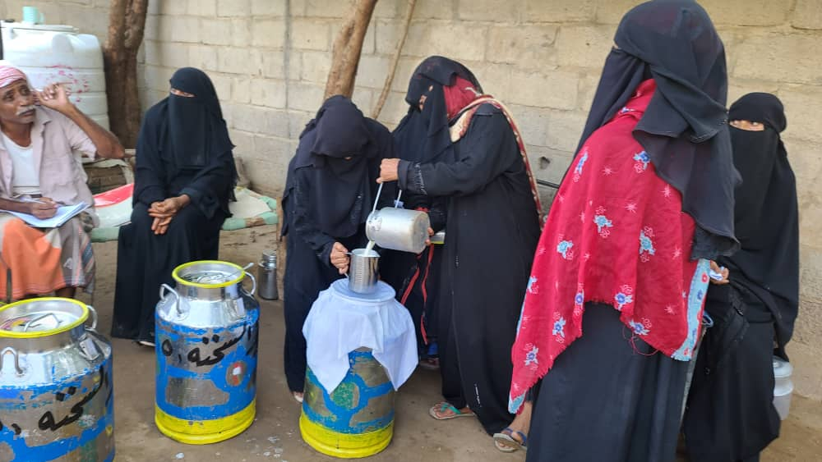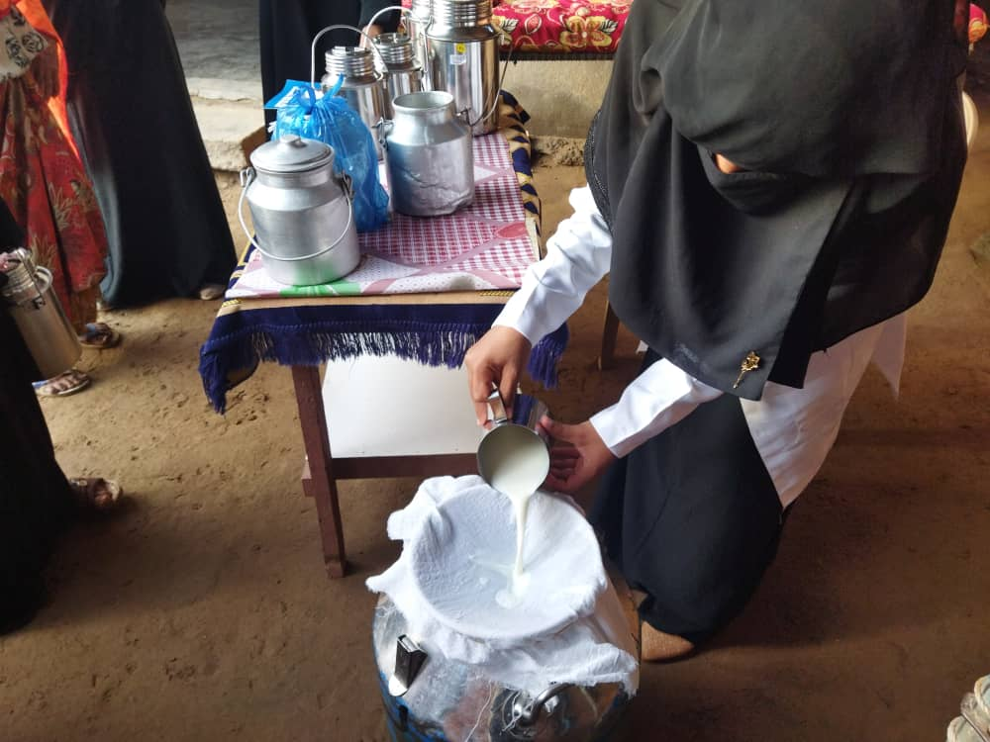
Women at a dairy production training in Hodeidah. ©UNDP
The Value Chain Approach
Following the capacity development of 900 female dairy producers including grant provision to 600 of these, 18 producer groups were established through two (2) milk collection centres serving three districts in Al-Hodeidah. Fostering the collaboration with the milk marketing associations of Bait Al Faqih and Al Mansouria the dairy producers are now able to sell up to 32,000ltrs of milk daily generating around 14.5 million YER (approx. $27,300) per month to the leading dairy factory meeting market standards and demand. This enabled the company to establish a new business and production line for organic milk using the local dairy products rather than imported milk powder.
Word about the successes of these centres spread quickly and it was not long that around 600 additional dairy producers adopted the model. As an example, a group of 18 women in a village in As Sukhnah district established a collection centre investing with their own capital and getting advice from the project-trained women who also connected them with the factory.
These cases are a prime example of the success of the value chain approach which looked from input supplies and production to processing, trading and market demand.

Output 1.1: Strengthened local authorities’ capacities to respond to community needs for services in an inclusive and accountable manner.

Indicators | Year 4 targets | Summary of achievements | Status
Indicator 1.1.1: Number of gender-responsive District Capacity Development Plans [developed/implemented] with support of District Facilitation Teams with support of the EU-funded intervention.  Baseline: 0 (2019) | 40 districts | 45 gender-responsive District Capacity Development Plans developed. | Achieved
Indicator 1.1.2: Number of Community Structures in target areas that are connected to district authorities through arrangements for managing service delivery and conflict resolution.  Baseline: 0 (2019) | 35 | 45 Community Structures whose members are able to support district authorities in managing basic service delivery and conflict resolution. | Achieved
Indicator 1.1.3: Percentage of (i) women and (ii) youth [18-35] among participants of training activities of the project with increased knowledge/skills  Baseline: 0 (2019) | Women: 30%  Youth: 10% | - Women: 26%  (ii) Youth: 23%  A total of 3,751 participants (991 women and 856 youth  Training topics included:  - Public Expenditure Management (PEM),  - Participatory planning and service delivery monitoring,  - Gender and youth sensitive approaches,  - Local governance system,  - Conflict sensitive local governance,  - District Risk Management,  - Data management,  - Basic Administrative and Financial Training. | - Partially achieved.  - Achieved
Indicator 1.1.4: Percentage of District Authorities with functional Women’s Affairs Units  Baseline:7% (2019) | 60% | 47% | Partially achieved

Capacity development – in the broader sense of institutional, organizational and individual capacities – is one of the key pillars of the Project. Its most obvious aim is to immediately improve the performance of local authorities to provide effective and responsive public services to the people of Yemen. The Project has also strongly emphasized the correct application of the strengthened capacities, linking it, through the Performance Principle, to the eligibility and allocation of Local Resilience & Recovery Funds. This intricate (and, as it necessarily turned out, adaptive) system of capacity development interventions, lastly, is one of the most important tools of the Project to ensure sustainability beyond the project’s duration.

With a focus on sustainability the project has leveraged existing competencies and expertise to establish inclusive structures (DFTs, DCTs) at the local level to promote local governance and local development. In its efforts to strengthen linkages between district authorities and communities, the Project has also supported the activation of representative community structures, such as community-based organizations (CBOs), community committees, private sector entities, youth initiatives, women groups, and community leaders.

These community structures were accompanied through a rigorous training programme that equipped them not only with key skills and knowledge for gender-sensitive development planning but also with technical expertise, such as governance, participation and conflict resolution and others as per the needs identified in the collaboratively developed capacity development plans, such as local governance and community participation. This was complemented by piloting social accountability initiatives and rounded up by investments in necessary hardware for local authorities.
Across all activities the project paid attention to meaningful participation of women and youth allowing not only their voices to be heard and needs be considered but also being reflected where applicable in tools, materials and methodologies.

The structures have become an integral part of local authority processes and for each of these processes the local authorities now have methodologies and tools at hand that allow for replication and repetition but also adaptation for other areas. And this goes beyond the local level. Also, the Ministry of Local Administration (MoLA) centrally updated its materials and manuals and therefore can now also guide together with local authorities the dissemination and application of improved methodologies and models to districts and governorates which are outside the scope of the Project but have become interest in its approach.
Due to these diverse capacity development initiatives, the aforementioned structures have played a crucial role in strengthening local authorities, fostering dialogue, promoting community participation, and ensuring that the needs and priorities of local communities are integrated into district-level planning and decision-making. These efforts form the foundation for the second and third key steps of the SIERY approach—Planning and Granting (the first being training), as outlined in Output 1.2.
“The SIERY Project stands out for its collaborative approach. By working closely with us from the outset and empowering our community, the Project fostered a strong sense of ownership. The gradual capacity building, institutional support, and inclusive engagement of various stakeholders culminated in our ability to prioritize and fund local needs. This process significantly strengthened trust among us as local authority, civil society, and community members.”
Salem Al-Atishi, Director of Ghail Bawazir District

Activity 1.1.1 Governorate authorities have the capacities, tools, and incentives to provide better technical guidance and capacity development to district authorities.

In the previous reporting period, training and capacity development were successfully completed in the IRG areas. However, advancing these efforts in the DFA controlled areas required intensive coordination.
Despite initial resistance from SCMCHA, which opposed activities promoting equity, gender, and youth inclusion, the Project managed to successfully develop a training manual on gender and youth-sensitive approaches in recovery and development. After extensive negotiations involving UNDP senior management, the SIERY project team, and the RP team, the training manual was finally approved following numerous revisions and contextualization. The involvement of the head of the Gender Studies Center at Sana'a University, who also serves as head of the Women Development Department at the Ministry of Local Administration (MoLA), proved crucial to this approval.
Following the approval, the Project quickly conducted training for 49 members of the District Facilitation Teams (DFTs) from Hajjah, Hodeidah, Ibb, Sana'a, and Taiz. These DFTs, representing governorate authorities, were equipped with the necessary capacities, tools, and technical guidance to implement gender and youth-sensitive approaches at the district level. They were able to transfer these trainings to the District Recovery Platforms (DRPs) of each targeted district with a focus on the DCTs.
Given challenges in the DFA controlled areas, including the usual animosity and obstruction by the DFA of the international community efforts to promote greater participation of women, this achievement is remarkable. It underscores that intensive interaction with relevant authorities, only made possible by of the ‘boots on the ground’, can yield positive results.

Activity 1.1.2 Linkages between district authorities and communities are strengthened through the activation of representative community structures.

In the IRG areas this work was completed in the last reporting period.

After a process of heavy scrutinization of training material by SCMCHA, which caused some delays, training in the DFA controlled areas was successfully completed. A total of 432 representatives of CSOs (34% women, 66% men) have now been trained on "Local Governance System from Knowledge to Practice”. This training enhanced their understanding of the local governance system, the rights and duties of CSOs, and has made them feel more capable of conducting community participatory planning, conflict-sensitive development, and local governance in Yemen.

The six-day event "Contribution of Local Actors with the Local Authorities in Resolving Dispute over Development Projects" aimed to increase the capacity of community structures to address various types of developmental-related conflicts and disputes. The event saw the participation of 447 local actors (19% women, 81% men) included influencers from youth groups, women’s groups, the private sector, and influential leaders. The low percentage of women amongst the participants highlights their limited influence at the district level, but it was encouraging to see a high youth participation rate of 29%.

These trainings were a crucial step in improving the capacities of community structures representatives to be active members of the District Recovery Platform in the district. They help link these representatives with members of the local authorities in a collaborative planning process and in selecting priorities for their district.

Activity 1.1.3 District authorities are more capable of assessing needs, planning, implementing, and reporting on their achievements in a participatory and inclusive manner.

Following the institutional assessment and development of capacity building plans conducted in the previous reporting period, the Project implemented targeted training programs for each district/governorate based on their specific needs. These tailored trainings focused on enhancing skills and knowledge essential for improved general institutional performance, covering several topics as detailed below:
Service Improvement: The training program was conducted in five governorates and 23 districts, covering 14 departments over six days. It aimed to build the capacity of local district authority members, to activate district departments, and to develop a mechanism for enabling district authorities in assessing needs, planning, implementing, and reporting on their achievements in a participatory and inclusive manner. It reached 272 employees, including 248 men and 24 women and contributed to enhancing the efficiency and effectiveness of district departments and improve the services they provide to local communities.
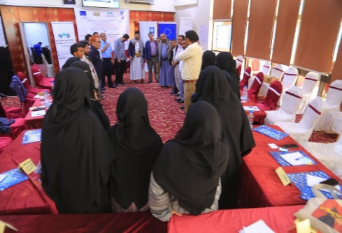
Disaster Risk Management: The training engaged 121 participants (14 women, 107 men) from Lahj, Hadramawt, and Marib governorates on topics such as disaster risk management (incl. analysis and assessment), disaster preparedness and disaster response at the local level. The relevance and urgency of this training was quickly demonstrated in Hadramawt: the local authorities already benefitted from this training during the recent floods in Mukalla, with the emergency committee having had assessed the readiness for an upcoming low-pressure system and already set up coordination mechanisms among civil, military, and security authorities in April 2024.
During a raining on disaster risk management for members of DRPs in Marib Governorate. ©UNDP

Project Management: A total of 33 participants (7 women, 26 men) in Taiz enhanced their skills in project design and implementation. This training significantly improved their ability to contribute to project planning and organization, marking a key advancement in local capacity building and sustainable development efforts in Taiz. As a result, the region is progressing toward Area Based Development more swiftly than other governorates.
Strategic Planning: A four-day workshop equipped directors of the Aden Planning Office with essential knowledge and skills in strategic planning methodologies and tools, enabling them to implement effective planning processes.
Strengthening of data management systems (incl. ICT) at district authorities: The Project upgraded the data management system in all 45 districts addressing the previously identified needs and providing ICT equipment to selected departments. These improvements give districts access to more current data, allowing for the creation of evidence-based District Development Plans (D2RPs) with reliable budgets. Accompanying the hardware installation, a Data and Information Management course trained 321 participants (82 women, 239 men) from Hadramawt, Lahj, Marib, and Taiz in effective data management practices to inform local authority decision-making.
Distribute micro-grant and coaching to local CSOs to pilot social accountability initiatives methods on service delivery and revenue management:
The Project bolstered local authorities' engagement with civil society organizations (CSOs) to enhance social accountability. This initiative fostered collaboration between local authorities and community structures, empowering CSOs to strengthen their skills in local development and social accountability.

Thirty CSO representatives (21 men, 9 women) were selected from 22 targeted districts in Aden, Taiz, Hadramawt, Lahj, and Marib out of a pool of 371 applicants. Selection criteria included valid permits, a minimum of two years of experience, proven social accountability activities, collaboration capacity with local authorities, operational offices, and established financial and administrative systems.

From May 21 to 25, 2023, a five-day training course on Social Accountability was successfully conducted in Aden. The CSO participants emerged with vital knowledge and skills to actively engage in governance processes, ensuring accountability of public institutions and fostering a more transparent and inclusive governance framework. They gained a solid understanding of social accountability, its significance, and effective implementation strategies. The training also equipped participants with essential competencies in project design, proposal writing, community engagement, monitoring and evaluation, data analysis, advocacy, and communication.

Following the training, CSOs developed project proposals for community initiatives. A selection committee evaluated these proposals based on criteria including competency, hearing sessions, project proposals, budgets, and community contributions. Nineteen (19) organizations - three from each governorate - were selected based on their scores and submission of required documentation. These organizations received grants ranging from $2,000 to $7,000 to pilot 19 social accountability initiatives in various sectors, including education, youth, health, and public works. These initiatives reached a total of 485,613 Yemenis.

One example of a successful social accountability initiative is the Bin Habrish Foundation for Development (BHFD) in Seiyun, Hadramawt Valley. With a $6,740 grant, BHFD implemented a community accountability initiative to improve women's privacy within the Seiyun Primary Court building. Through public participatory hearings, BHFD identified priority needs and successfully advocated for the establishment of a women-friendly courtroom and the production of an educational video on women's legal rights.

Similar steps were followed in the DFA controlled areas, where nine local CSOs were selected from 159 applicants. While these CSOs were new and lacked gender representation, the project decided to proceed with capacity building and training on social accountability. However, due to factors such as the nature of the ideas raised and interference from central authorities, grants were not provided for on-the-ground initiatives. Nevertheless, the primary goal of raising awareness about community accountability was achieved.

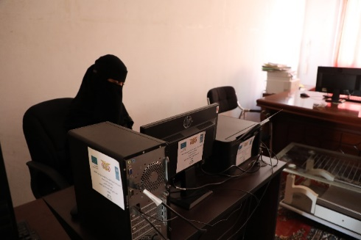
Institutional and capacity-building support to Women’s Affairs Units and women staff in district Diwans: Institutional support to Women’s Affairs Units and Women’s Department at the governorates and districts level has been extended to the provision of office and ICT equipment (e.g., chairs, desks, filing cabinets, computer desktops, printers, and others) to allow the women’s units to function and provide services.
A staff member of the Women’s Affair Unit in Ghail Bawazir District using the ICT equipment supported by the SIERY Project. ©UNDP

Activity 1.1.4 District authorities manage their human and financial resources more efficiently and accountably.

Within the context further detailed under section 3.5. the envisaged work on Accountability Standards remains sensitive. While there is an understanding of the urgent need in the IRG area, the situation in the DFA controlled area is more complex. The suspension of operations for the selected Responsible Party has revealed significant resistance from authorities. As a result, the related activities have been de-prioritized in the DFA controlled area. In the IRG area implementation was only able to start at the end of the reporting period.

Output 1.2: Improved capacities of public service providers for scaling up the outreach to the most vulnerable

Indicators | Year 4 targets | Summary of achievements | Status
Indicator 1.2.1 Percentage of women in representative structures as part of SIERY intervention (Community Structures, District Recovery Platforms).  Baseline: 0% (2019) | 20% | 28% of members in Community Structures across nine governorates are women. | Surpassed
Indicator 1.2.2 Number of gender-responsive recovery plans (a) for service delivery (district), (b) for the local economy (governorate) [developed/implemented] with support of the EU-funded intervention.  Baseline: a) 0: b) 0 (2019) | a) 100  b) 10 | a) 134 gender-responsive recovery plans for district service delivery implemented across nine governorates.  b) Six (6) gender-responsive recovery plans for the governorate's local economy are completed. | Achieved
Indicator 1.2.3 Number of local authorities’ representatives trained in locally relevant topics with support of the EU-funded intervention (disaggregated by sex).  Baseline: 0 (2019) | Total: 400 local authorities  Women: 120 (30%)  Men: 280 (70%) | Total: 654  Women: 198 (30%)  Men: 456 (70%) | Surpassed
Indicator 1.2.4 Number of district- and governorate-level projects funded via the LR2F.  Baseline: 0 (2019) | 150 district- and governorate-level projects | 167 district-and-governorate level projects funded via the L2RF. Breakdown:  45 district- and governorate-level projects (2021 L2RF) completed.  60 district- and governorate-level projects (2022 L2RF) completed.  62 district- and governorate-level projects (2023 L2RF) are ongoing. | Surpassed
Indicator 1.2.5 Number of students benefiting from schools’ rehabilitations disaggregated by sex.  Baseline: 0 (2019) | Total: 225,000  Girls: 115,000  Boys: 110,000 | Total: 104,823  Girls: 64,898  Boys: 39,925 | Partially achieved
Indicator 1.2.6 Number of districts with increase of investment budget (actual) through funding of priority projects through L2RF  Baseline: 0 (2019) | 43 districts | 45 districts  21 districts in the IRG area and 24 districts in the DFA controlled area have increased their investment budget (actual) by funding priority projects through L2RF. | Achieved

“The inclusion of persons with disabilities in the recovery plan was a significant achievement. It demonstrated recognition of their rights and a commitment to empower them."
"The training experience in the SIERY Project was invaluable. It provided me with knowledge and skills to represent people with special needs and meet their needs."
Mr. Ayoub Mohammed, Tarim district, Hadramawt governorate, a member of the Himm Association for Persons with Disabilities and the empowerment officer at the Integration Development Foundation

Based on the achievements of the capacity development approach (output 1.1), the Project successfully institutionalized District Resilience Platforms (DRP) as a mechanism for the promotion of local governance and development. The Project linked the DRP to the Local Economic Development (LED) Platforms which, through joint assessments and public-private partnerships, are instrumental for the identification of local economic development opportunities.

The composition of the DRPs - local authorities’ members and community networks - enhanced regular dialogues between district authorities and community representatives and thereby promoted mutual understanding and collaboration towards recovery and local development. Especially the fact that the voices of the communities were heard through their meaningful participation in the development of annual and multi-year district plans, budgets, and service delivery prioritization has resulted in more responsive and inclusive governance at the district level, as demonstrated in the D2RPs tailored to the specific needs of each district.

The broad outlines of the project’s implementation ‘infrastructure’ (DFTs, DCTs, DRPs, etc.), method (capacity development, participatory recovery and development planning, and prioritization), and approach (strong emphasis on collaboration between local authorities, communities and businesses) have been tailored to specific regional circumstances, diverse governance ‘traditions’, and relationships between local authorities and communities. The project team is confident that where the approach is institutionalized it will contribute to the restoration of trust in the institutions. The local authorities in Hadramawt, Hajjah, Marib and Ta’iz (IRG part), in recognition of both the practicality and the potential of the Project’s ‘approach’, have adopted and institutionalized it for use in districts outside the Project’s scope, a clear recognition of its relevance.

Activity 1.2.1. Pathways for resilience and recovery of basic and social services are identified by inclusive local platforms and reflected in annual plans.

The District Recovery Platforms (DRPs) are integral to SIERY's approach for enhancing resilience and recovery in Yemen. Composed of diverse local stakeholders, DRPs facilitate the identification of pathways for rebuilding basic and social services. Their inclusive participation fosters improved planning, coordination, and strengthens trust between civil actors and authorities.

SIERY trained DRP members to lead local recovery efforts, focusing on participatory planning. By collaborating with local authorities, civil society, community groups, women's and youth initiatives, and the private sector, DRPs enhance stakeholder coordination and public service delivery effectiveness.

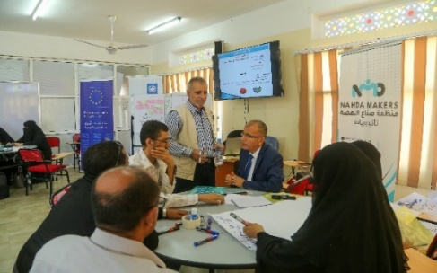
DRPs are playing a key role in building trust and reinforcing the social contract between communities and authorities. SIERY supports selected DRP initiatives to demonstrate their model’s effectiveness and promote replication in other districts. To ensure the sustainability of DRPs, SIERY has focused on institutionalizing these platforms through capacity building and formalization, providing training in communication, coordination, and planning. Additionally, DRPs have developed operational manuals to ensure ongoing effectiveness.
Photo: Training on Leadership and Communication Training for members of DRPs in Taiz governorate, October 2023. Photo Credit: UNDP

In the DFA controlled areas, the SIERY team was able to continue the strengthen of the functional capacity of these DRPs, 460 members (136 women, 324 men, 60 youth) from Hajjah, Hodeidah, Ibb, Sana’a, and Taiz governorates in leadership, communication, and cooperation. Building on these skills, DRPs developed 23 three-year District Recovery Plans. To institutionalize these platforms, a procedural guideline was developed to support local authorities in leading the recovery and development process.

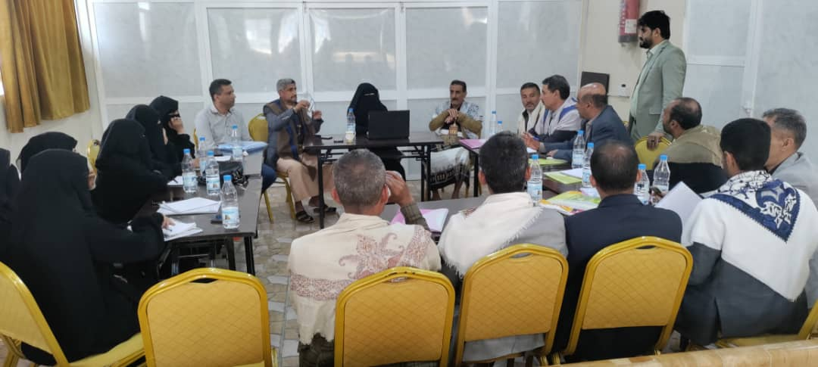
In the IRG areas, as a continuation of all capacity building efforts that took place in the previous reporting period, DRPs received training on developing three-year District Recovery Plans. A total of 445 participants, including 148 women and 94 youth, were involved in these training sessions. Additionally, DRPs were engaged in discussions on their continuity and trained on the operational manual.

In total, SIERY facilitated the development of three-year District Resilience & Recovery Plans (D2RPs) (2024 -2026) in 45 target districts, outlining investment and capacity-building needs for key sectors. The active leadership of local MoPIC offices during the DRP development process was instrumental in garnering broad ownership of these plans. SIERY's efforts empowered DRPs to play a pivotal role in fostering resilience and recovery in the targeted districts. By facilitating local collaboration, promoting participatory planning, and building capacity, DRPs emerged as effective platforms for rebuilding basic and social services. These platforms established locally owned pathways for sustainable development and stability in the affected areas.
Local authorities preparing recovery and resilience plans in Jiblah District of Ibb Governorate in November 2023. ©UNDP

In the IRG area district service delivery audits were piloted in six (6) key sector areas with DRPs' participation including the following components:

2. Training on district service delivery audits:
A four-day training covered the methodology, models, tools and procedures of internal control and audit of projects and public services. A total of 123 (22 women, 101 men) staff from the Finance Office, Office of Audit and Inspection, Governorate Offices, and Administrative Control were able to obtain the skills and knowledge to conduct, prepare for or oversee such audits in the future to ensure the effective implementation of internal control and auditing of public projects and services. This manual was designed in accordance with Yemeni laws, local authority laws, and regulations and incorporated the provisions outlined in the re-establishment and organization of the internal control function in the units of the central administration of the state and the public and mixed sectors.
- Development of a training manual:
A comprehensive training manual was developed to ensure the effective implementation of internal control and auditing of public projects and services. This manual was designed in accordance with Yemeni laws, local authority laws, and regulations and incorporated the provisions outlined in the re-establishment and organization of the internal control function in the units of the central administration of the state and the public and mixed sectors.

In the IRG areas, the Project was able to deliver an extensive training program in six governorates (Taiz, Aden, Marib, Lahj, and Hadramawt (Al Wadi and Al Sahel) to align the work of the relevant offices with the Republican Decree No. 5 of 2010, which restructured internal audit practices in an attempt to restore the functionality of the local internal control and service delivery auditing. This enabled the Project to align key activities, designed five years ago, with actual institutional developments in Yemen, thereby maximising the impact.
123 participants, including 22 women, from finance offices, audit and inspection offices, governorate offices, and administrative control departments attended the training. As a result, the awareness of internal audit process has improved, which has further empowered managers of internal audit departments. The participants improved[1] their understanding of the necessary requirements and guidelines for the practical application of relevant decrees and manuals. The training covered topics such as the definition of internal audit, principles governing relationships between internal audit management and other departments, planning and conducting internal audit activities, and preparing audit programs and working papers. The training provided a very hands-on experience through brainstorming, group work, and case studies, ensuring an interactive learning environment that connected theoretical principles with practical experiences. Participants gained the ability to prepare strategic and annual audit plans, conduct strategic analysis using SWOT methodology, and integrate internal audit activities with external auditors' work. Despite challenges (such as participants' varied backgrounds and lack of managerial support), recommendations were made to further strengthen the audit function, including increased budgets, adoption of digital technologies, and awareness programs for local authority leaders.
Based on these recommendations, the project is taking steps to strengthen accountability resilience at various levels. At the central level, a comprehensive assessment of training needs will be conducted, followed by targeted training, technical support, and a Training of Trainers workshop. At the governorate level, assessments of training and equipment needs will be conducted, and technical and logistical support will be provided. A comprehensive study on resource management will also be undertaken, and district-level control management will receive training.
At the district level, a district-level accountability improvement plan will be further developed and implemented, and institutional support will be provided to resume government accounts auditing. The upcoming report period will reflect the progress made in implementing these initiatives.
This, in turn, contributed to improved financial management, risk identification and mitigation, and overall governance and accountability within the local authorities. It was noted that the service delivery audit package would have benefitted from the inclusion of “practical exercises” for which there regrettably was not sufficient support and buy-in from the Ministry of Local Administration. The Project has continued to encourage targeted Governorates to do so, however small and innocuous.
Unfortunately, in the DFA controlled areas, activities on service delivery audits could not be implemented due to the topic's sensitivity. Despite repeated (and drawn out) engagement with the central authorities in Sana’a (mainly SCMCHA), buy-in and thereby approval for the activities could not be obtained. More broadly, this reluctance to engage with the project on assessment and audit type of activities (in addition to community engagement type of activities) reflected the mistrust and suspicions of the DFA in the motivation of UNDP, seen as a representative of the international community, to conduct these. This challenge is discussed further in Chapter 3.5.

Activity 1.2.2. Key sustainable development dimensions (local economy, resilient urbanization) are considered by local authorities and initial actions taken in line with the SDGs.

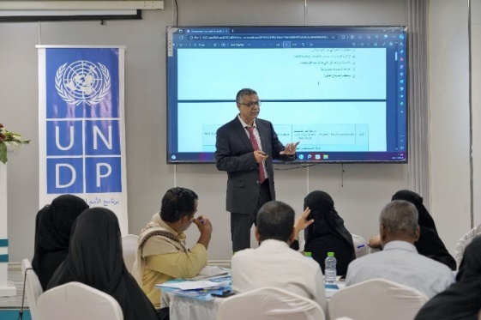
The Collaboration Platforms for Local Economy Recovery (CP4LER) in Aden, Lahj, Hadramawt (valley and coastal), Marib, and Taiz continued to be supported as they progress with the planned activities. Representatives from public, business, and non-governmental sectors used their recently enhanced skills (LED principles, local economic assessment, LED strategy development, public-private partnerships, and revenue generation, among others), to conduct comprehensive diagnostics of the local economy, business environment, and productive sectors in their governorates. The LED diagnostic studies provide valuable insights into the local economic landscape, identifying key opportunities and challenges for local economic development, and potential policies and approaches to (sectoral) growth stimulation.
Findings of these studies were discussed and validated in workshops that brought together local authorities, private sector representatives, and civil society organizations, fostering further collaboration and coordination. In addition, an online platform (الرئيسية | منصة التنمية الاقتصادية المحلية في اليم (yemenledambassadors.com) was created to facilitate information sharing and the exchange of experiences among members of the CP4LER and services, a valuable tool for collaboration and learning.
During the presentation of the findings of the economic diagnostic study in Hadramawt in November 2023. ©UNDP
As part of its efforts to improve the capacities of public service providers, the project aims to strengthen local authorities on key sustainable development dimensions, including resilient urbanization (SDG 11). By supporting sub-national authorities to initiate and take actions aligned with SDG 11, the project seeks to increase the resilience of selected urban centers in targeted governorates.

After extensive consultations and reviews, four governorates were selected for the resilient urbanization component: Hajjah and Ibb in the DFA controlled areas, and Taiz and Marib in the IRG areas. The selection was based on these cities’ urbanization potential, rapid growth, and significant IDP populations. The training takes the unique urban institutional context in Yemen into account, including the lack of legal 'municipal authorities’ as such, the on-going conflict, the role of cities in accommodating large numbers of IDPs, including climate refugee emphasizes a "whole-of-city" approach to urban governance.

The Project supports local authorities in these four governorates by addressing institutional gaps at the urban/municipal level, the division of labour between city districts and governorates, and the impact of the conflict on urban planning and public service infrastructure. The activities emphasize innovative solutions to manage the social, economic, and political consequences of rapid urbanization and IDP influx.

As of now, the RP is already selected, and the Project has conducted stakeholder engagement and coordination with local authorities in both the DFA controlled and the IRG areas. While negotiations with SCMCHA in the DFA controlled areas are ongoing, the project anticipates final coordination decision by the end of September 2024. In the IRG targeted areas, both MoLA and MoPIC have granted necessary permissions to proceed. The establishment of Urban Planning & Management Teams (UPMTs) with active local authority involvement has commenced. While tangible results are expected in the IRG areas, the DFA controlled areas may face challenges due to the current security situation and potential opposition to capacity development activities. The project is discussing alternative strategies to maximize impact in the IRG areas if activities in the DFA controlled areas are not feasible.

Activity 1.2.3: Multi-purpose local recovery funding supports the implementation of local priorities.

For the fourth consecutive year, the SIERY project has made significant strides in addressing prioritized needs outlined in District Recovery Plans (DRPs) through the Local Resilience and Recovery Funds (L2RFs). As a cornerstone of SIERY, L2RFs are allocated to local public priorities identified collaboratively by local authorities, communities, and other stakeholders. This process, which follows a rigorous three-stage SIERY planning cycle, is preceded by capacity development in Public Expenditure Management (PEM).

L2RFs are characterized by their discretionary nature, multi-thematic focus, and broad recipient base. They are designed to support all-of-district or all-of-governorate initiatives, aligning with the project's Description of Action. To enhance the Performance Principle, the L2RF instrument has been refined to prioritize local authorities' adherence to the PEM cycle and meaningful community participation. To ensure neutrality and national coherence, the UNDP Project Team directly manages L2RFs. The rigid sub-fund and funding window structure has been replaced with flexible allocation guidance principles, empowering sub-national authorities to leverage their processes, capacities, and priorities.

Following these steps, the project continues to move towards granting DRP priorities. Significant progress was achieved during this reporting period, where 54 local priorities/public sector investment projects in both the DFA controlled areas and the IRG areas reached a 100% progress rate out of the 60 L2RF 2022. However, five (5) projects in the DFA controlled areas and 1 in the IRG areas were not finalized due to factors such as delays in procurement and delivery of goods, the impact of the Red Sea conflict, the crisis of the banking sector in Yemen, and weather-related (floods, heavy rains) challenges.

2022 L2RF Priorities Progress
# | Name of project | Region | Sector | Gov | District | Progress rate %
1 | Rehabilitate the water scheme of Al Hawak Al olya, Al Guzaah neighbourhood in Al Hawak Al Olya | DFA | Water | Hodeidah | Al Hawak | 100%
2 | Rehabilitation of Al Rabasah neighbourhood | DFA | Water | Hodeidah | Al Hawak | 100%
3 | Rehabilitate the women handicraft institute | DFA | Vocational Education | Hodeidah | Al Munirah | 100%
4 | Asphalting and paving the main road of Al-Munirah | DFA | Road Infrastructure | Hodeidah | Al Munirah | 100%
5 | Rehabilitate the internal sanitation Network for the South part of Hajjah city | DFA | Hygiene Sanitation | Hajjah | Hajjah city | 100%
6 | Pavement improvement of Al-Mezaab _Al Qarara Road _Hajja City District _Hajja Governorate | DFA | Road Infrastructure | Hajjah | Hajjah city | 100%
7 | Complete, renovate and rehabilitate, Al dhenoobah Health center, equipment and furniture | DFA | Health | Hajjah | Najjrah | 100%
8 | Supply & install internal water network for Al Aman city | DFA | Water | Hajjah | Najjrah | 100%
9 | Rehabilitate and equip the kidney dialysis center in Abs city | DFA | Health | Hajjah | Abs | 100%
10 | Expand, rehabilitate & furnish Al Najah basic School in Al Mihabisha city | DFA | Education | Hajjah | Al Mihabisha | 100%
11 | Rehabilitate clinic in Ragaee sub district | DFA | Health | Hajjah | Mustaba | 100%
12 | Rehabilitation of the main road between Al Sayaf subdistrict and Ban Rasam sub district | DFA | Road Infrastructure | Hajjah | Mustaba | 100%
13 | Expansion of Al Mihabisha Hospital | DFA | Health | Hajjah | Al Mihabisha | 96%
14 | Water Harvesting Tank | DFA | Water | Ibb | Dhihar | 95%
15 | Rehabilitate and deepen the water project of Al-Dehthath through digging another well | DFA | Water | Ibb | Al-Mashana | 80%
16 | Fencing Agriculture Research Center | DFA | Agriculture | Ibb | Al-Mashana | 100%
17 | Build concrete harvesting water tank and its fence for Jiblah Water Project of the Water Corp | DFA | Water | Ibb | Jiblah | 90%
18 | Stone paving for roads connecting 3 villages, 6 sections. | DFA | Roads | Ibb | Jiblah | 100%
19 | Rehabilitate Hadaqat canal with the supporting wall and the damaged areas | DFA | Roads | Ibb | Dhi Sufal | 100%
20 | Establish Kidney Center in Yarim Public Hospital | DFA | Health | Ibb | Yarim | 100%
21 | Rehabilitate and furnish 22 classrooms in Khaled Bin Al-Walid high school for boys | DFA | Education | Ibb | Yarim | 100%
22 | Purchase and import Suction sewage vehicle for Manakha city | DFA | WASH | Sana'a | Manakha | 75%
23 | Import and install solar pumping unit and maintain the treatment station for water in Maidon area, Al-Sahman subdistrict | DFA | Water | Sana'a | Jihana | 100%
24 | Build and furnish 3 ground-floor classrooms for Um Al-Mumeneen Khadija school in Ghadhran area | DFA | Education | Sana'a | Bani Hushiesh | 100%
25 | Rehabilitate the health center in Saref subdistrict. | DFA | Health | Sana'a | Bani Hushiesh | 100%
26 | Complete the water project of Al-Akhlood area for the Rural Water Corp | DFA | Water | Taiz-DFA | Maqbana | 100%
27 | Rehabilitate the Water project of Al-Mashawiz, Bani Salah area for the Rural Water (Purchase and equip solar pump unit + solar systems) | DFA | Water | Taiz-DFA | Maqbana | 100%
28 | Rehabilitate the 22 May school in Esrar sub-district | DFA | Education | Taiz-DFA | Mawiya | 100%
29 | Rehabilitate Qutaiba bin Muslim school in Amamah sub-district | DFA | Education | Taiz-DFA | Mawiya | 100%
30 | Establish and equip a central maintainance workshop for the technical institute in Alhawban area. | DFA | Vocational Education | Taiz-DFA | At Taiziyah | 100%
31 | Providing equipment, transportation, hygiene tools and extractor hoods to deal with sewage overflow | IRG | Sanitation | Taiz-IRG | Al-Qahira | 100%
32 | Furnishing and providing chairs and laboratories for the directorate schools | IRG | Education | Taiz-IRG | Al-Qahira | 100%
33 | Lighting the district's streets with solar energy | IRG | Electricity | Taiz-IRG | Al-Mudhaffar | 75%
34 | Paving the directorate’s streets in the following neighborhoods (Thabat Street) | IRG | Public Works and Roads | Taiz-IRG | Salah | 100%
35 | Paving the directorate’s streets in the following neighborhoods (Al-Ashbat Street). | IRG | Public Works and Roads | Taiz-IRG | Salah | 100%
36 | Rehabilitation of the sewage network for the following neighbourhood (Al-Dar Street - Najd Al-Askar Street to Al-Thalathin Street). | IRG | Sanitation | Taiz-IRG | Al-Mudhaffar | 100%
37 | Rehabilitate the Old Fish Market | IRG | Economic Development | Lajh | Al-Hawtah | 100%
38 | Rehabilitation of Asphalt Road and maintenance of bridges in Khor Amira and Al Shatt Bridge | IRG | Public Works and Roads | Lajh | Al-Madhariba | 100%
39 | Paving the road of Al-Jami and Al-Hamishi neighborhood | IRG | Public Works and Roads | Lajh | Habil Jabar | 100%
40 | Paving and expansion of Aqabat Dhisra neighborhood | IRG | Public Works and Roads | Lajh | Yafa’a | 100%
41 | Building 6 classrooms for Al-Saeed Elementary School for Girls | IRG | Public Works and Roads | Lajh | Tuban | 100%
42 | Supplying and installing a computer lab for the academic complex + furnishing | IRG | Education | Hadramawt Alwadi | Al-Qtan | 100%
43 | Rehabilitating the water network of Madodahand Al-Ghurfah | IRG | Water | Hadramawt Alwadi | Seiyun | 100%
44 | Building and rehabilitating the rain drains to reduce future disasters | IRG | Public Works and Roads | Hadramawt Alwadi | Tarim | 100%
45 | Connecting the sewage of Al-Qatn General Hospital with the local sewage system | IRG | Sanitation | Hadramawt Alwadi | Al-Qtan | 100%
46 | Providing equipment to the Works Office in Mukallah district | IRG | Public Works and Roads | Hadramawt Alsahel | Al-Mukalla | 100%
47 | Furnishing and equipping the executive offices in the district | IRG | Local Authority | Hadramawt Alsahel | Ghail Bawazeer | 100%
48 | Completion of the solar energy project for 5 schools | IRG | Education | Hadramawt Alsahel | Al-Mukalla | 100%
49 | Supplying the wells in the Al-Udhaiba area with the solar energy system | IRG | Water | Hadramawt Alsahel | Ghail Bawazeer | 100%
50 | Changing the sewage line of the zone of 180 apartments to the sewage of the Ahmed bin Hanbal zone with maintenance | IRG | Sanitation | Hadramawt Alsahel | Ash Shihr | 100%
51 | Provide health equipment and furniture for Al-Luhoom health center - Dar Sad district | IRG | Health | Aden | Dar Saad | 100%
52 | Providing 14 schools + the MoE district office in the district with a solar energy system | IRG | Education | Aden | Dar Saad | 100%
53 | Rehabilitation of Al-Magzara water station | IRG | Water | Aden | Al-Buraiqah | 100%
54 | Rehabilitation of the decrepit sewage network and supplying it with pumps (Kod Al-Namer) | IRG | Sanitation | Aden | Al-Buraiqah | 100%
55 | Rehabilitation of the current water networks | IRG | Water | Aden | Al-Mansura | 100%
56 | Rehabilitation and paving of the Directorate's main and sub-roads. | IRG | Road infrastructure | Aden | Al-Sheikh Othman District | 100%
57 | Expanding the water supply in all areas of Khor Maksar | IRG | Water | Aden | Khur Maksr District | 100%
58 | Supply maintenance and tools requirements for implementation of sewage network - Al-dar Area, Bir Basha sub-district, Al Mudhaffar district, Taiz Governorate | IRG | Sanitation | Taiz-IRG | Al-Mudhaffar | 100%
59 | Supply maintenance and tools requirements for implementation of solar units - Al Mudhaffar district, Taiz Governorate | IRG | Electricity | Taiz-IRG | Al-Mudhaffar | 100%
60 | Supply maintenance and tools requirements for supply and transport double chairs to schools in the Al-Qahira Directorate - Taiz Governorate | IRG | Education | Taiz-IRG | Al-Qahira | 100%
Following the selection of 70 local priorities for L2RF2023 funding, six (6) out of the eight (8) RPs successfully transitioned to this third round of L2RF implementation. Current projects span essential public services, including education, energy, health, roads, sanitation, and water, with solar power being a key element. Most of these selected priorities have already progressed with needs verification, technical assessment, social and environmental assessment, the development of technical specifications and Bills of Quantities (BoQs) and tendering of goods and services.
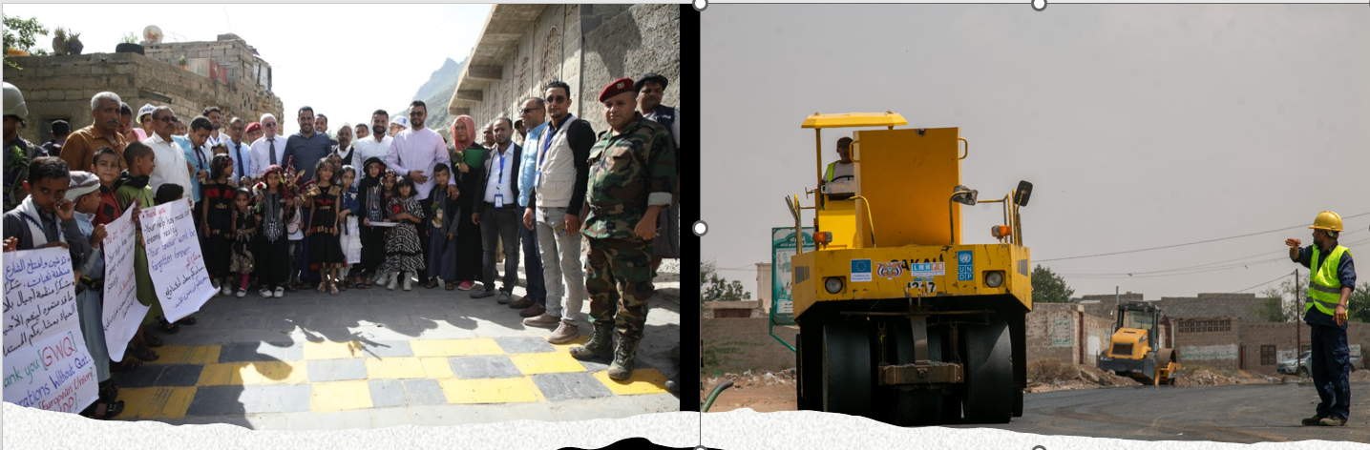
The launch of a newly rehabilitated street Taiz. ©UNDP | Construction workers asphalting main roads of Al-Munirah District, Hodeidah. ©UNDP

Despite facing challenges such as limited access in the DFA controlled areas and restrictions imposed on RPs, the Project is on track. Completion of priorities in the IRG areas is anticipated by December 2024, while those in the DFA controlled areas are expected to extend into the first quarter of 2025.

The L2RF process, facilitated by the Project Team and UNDP Yemen, is producing substantial results that contribute to local recovery and development. It is not merely a financial mechanism but rather an integral part of SIERY's transformative approach. It empowers local governance structures, promotes community participation, and fosters ownership and accountability. By aligning investments with local priorities, the L2RF ensures the relevance and sustainability of projects, improving the lives of Yemen's most vulnerable populations.
Testimonies of Impact and Recognition
Hala, a student at Khawla Bint Al-Azwar School, noted improved classroom conditions leading to better focus and educational outcomes.
A parent at Zainab School for Girls remarked that new ceiling fans and lighting made students feel more energetic.
Dr. Fayez Badar, Director of Ghail Bawazeer Hospital, stated that funding has significantly boosted surgical capacity and community service.
Local authorities also acknowledge the positive influence of SIERY. Eng. Arif Al-Yosifi, District Manager of Salah, emphasized that the project revitalized local governance, enabling services for over 50,000 people.

Activity 1.2.4. Integrated support to restoring education services in affected communities helps restore livelihoods, stability and social cohesion.

The capacity-building for local education providers was finalised at the end of the last reporting period.

To further enhance and revitalize educational services, the project implemented a comprehensive initiative to equip schools with essential furniture. This included chairs and desks for administrative offices and classroom benches. This effort complemented previous initiatives in the DFA controlled areas, such as school infrastructure rehabilitation and sustainable solar energy system installations. The timely delivery of these vital resources coincided with the start of the new academic year, ensuring optimal learning environments for students. This initiative reached six schools across Hajjah, Sana’a, and Ibb governorates.

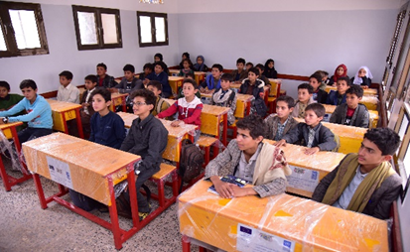
In total, this support benefited 3,905 students (2,631 girls and 1,274 boys). The schools received 559 classroom benches and were furnished with office desks, revolving chairs with arms, office chairs, stackable chairs, wooden office cabinets, and school lab cupboards for their administrative offices.

Students receiving a lesson in one of the schools that has been equipped with desks and chairs by Jehana local authorities with support from the SIERY project.

# | Name of the School | Gov | District | Number of students |  |  | Classroom Benches | Office furniture
 |  |  |  | Girls | Boys | Total | Classroom Benches | Office furniture
1 | Fatimah Al Zahra School for Girls (Basic and Secondary school) | Hajjah | Hajjah City | 899 | 0 | 899 | 285 | X
2 | Arwa elementary and illiterate school for girls | Ibb | Jibla | 820 | 0 | 820 | 0 | X
3 | 22-May Elementary and High School for boys and girls | Sana’a | Al-Haymah Al-Kharijiyah | 148 | 302 | 450 | 84 | X
4 | AL-Emam Zaid Basic School for boys and girls | Sana’a | Al-Haymah Al-Kharijiyah | 91 | 187 | 278 | 40 | X
5 | Ezz Addin (Basic and Secondary school) for boys and girls | Sana’a | Jihana | 190 | 275 | 465 | 50 | X
6 | Khawlah (Basic and Secondary school) for boys and girls | Sana’a | Jihana | 483 | 510 | 993 | 100 | X
Total |  |  |  | 2,631 | 1,274 | 3,905 | 559

Output 1.3: Strengthened central-local and horizontal relations between local governance stakeholders.

Indicators | Year 4 targets | Summary of achievements | Status
Indicator 1.3.1: Number of dialogue events between local and central authorities with the support of the EU-funded intervention.  Baseline: 0 (2019) | 1 dialogue event | The dialogue had to be postponed to September. | Partially achieved
Indicator 1.3.2: # of women’s affairs units in targeted central administrations producing gender mainstreaming strategy notes, guidelines facilitation/support or tools with support of the EU-funded intervention.  Baseline: 0 (2019) | 4 women’s affairs units | 1 national gender mainstreaming strategy | Achieved
Indicator 1.3.3: % of Yemeni women among local governance representatives at international peer exchange events organised with support of the EU-funded intervention.  Baseline: 0 (2019) | 20% | 9%  There was no international peer exchange event conducted during the reporting period. | Partially achieved

Since the outbreak of the conflict (and, arguably, even before 2015), institutional arrangements in Yemen have been in flux. This process gained new impetus in the reporting period, especially in the IRG controlled areas, with numerous initiatives at the central (especially by the President’s Office) and local level (especially Taiz, Hadramawt, al Mahrah, and Marib). This process, which takes place in a volatile and uncertain political environment, is still evolving, and it is too early to predict the outcomes at the short term, let alone what will be – eventually – formalized.
Therefore, as in previous years, a sufficiently clear and comprehensive institutional framework is lacking to provide guidance to base formal improvements in the functional relationships between the central and sub-national authorities on through regulatory and institutional measures. Therefore, the Project has seen a shift to ad-hoc, informal, and especially experimental platforms, procedures, mechanisms etc. which is reported under output 1.1. and 1.2.

However, the Project significantly enhanced “horizontal relations” among local authorities (IRG areas) at the district and governorate levels. By rewarding high-performing local authorities in planning, participation, and local cooperation, the project incentivized collaborative approaches. For instance, the MoPIC Office in Aden facilitated visits through DFTs to non-project districts. These DFTs assisted in planning and adopting the SIERY mechanism, a tool for prioritizing districts plans and encouraged the peer visits between these districts. Additionally, visits were organized for these districts to learn from project-targeted directorates.

Similarly, the Planning Office in Lahj engaged in exchanges with Aden and Taiz governorates to improve institutional resilience and to learn from the Taiz Area Based Development approach. Marib Governorate collaborated with Hadramawt Governorate's Education Office to share experiences and expertise in education development.

The Project also fostered stronger relationships between women's organizations. The workshop on coordination frameworks revitalized communication and cooperation among the Women's Development Department, its governorate and directorate offices, the Yemeni Women's Union, and the National Women's Committee.

Throughout writing this report, numerous workshops and cooperative meetings were held, bringing together targeted governorates and districts with the Ministry of Local Administration. These gatherings generated recommendations and proposals that will inform suggestions and recommendations to enhance central and horizontal relations between all these actors. The upcoming report will embody all of these outcomes once verified with participants and representatives of these entities.

Activity 1.3.1. Regulatory and institutional measures needed to restore functional central-local relations are taken.

One of the key assumptions of the project is that the ‘fragments’ of the former unified Yemen state, whether it be the ‘South’ and the ‘North’ or the different Governorates of the ‘South’, are not inert pieces waiting to be put together again, but are energetically evolving and developing further, finding practical solutions to new governance problems (or ideologies). In fact, many Governorates in the ‘South’, with or without the assistance of the project or the international community, come up with effective and practical resource, policy and/or service delivery solutions that have the potential to provide building blocks for an effective and often more inclusive future unified Yemen.

In the absence of formal regulatory and institutional reforms, the Project has adopted a "building blocks" strategy to foster effective and inclusive central-local relationships. This approach is essential for a more stable and sustainable institutional framework post-peace phase.

Over the past four years, the Project has invested significantly in strengthening relationships between central government and local authorities through coordination and a bottom-up planning approach, as well as among different local authorities. Recognizing the vital role of these connections in achieving effective governance, the project recently celebrated its fourth anniversary with a landmark workshop within the IRG areas held in Mukalla, Hadramawt Governorate.
This workshop brought together around 30 participants from central, governorate, and district levels of government. The event provided a platform for:
- Representatives from the Ministry of Local Administration shared insights on the Local Administration Law and the role of the Ministry in supporting local authorities.
- Local authorities discussed their visions, experiences, and recommendations for improving local governance.
- Participants engaged in constructive discussions on enhancing communication, finding practical solutions, building partnerships, and improving service delivery.

The workshop yielded valuable recommendations for central and local authorities, as well as development partners. It is considered a significant step towards empowering local authorities in Yemen by fostering dialogue and identifying priorities for the future.

The Project organized the “Experience Exchange Workshop”, inviting local governance actors (mainly from the respective Governor’s Offices) from Aden, Lahj, Hadramawt, Marib, and Taiz.

This workshop provided the platform for local authorities to share their experiences to foster cooperation, facilitate mutual learning, and enhance the organizational, managerial, and technical capacities of executive offices. Aden governorate hosted the workshop on financial and human resources, while Taiz governorate shared experiences related to financial management. Similarly, local authorities of Hadramawt and Marib shared experiences and expertise in the areas of education (Hadramawt); hygiene and sanitation, and project management/implementation (Marib).
It is important to highlight that the main impetus for these exchanges came from the authorities based on their positive experience with the SIERY approach and the clear understanding that such exchanges are beneficial to their work and their staff and will enhance the capacity of executive offices in local authorities to make informed decisions, effectively address local challenges, and improve performance and effectiveness in the delivery of local services.
Acknowledging this successful activity, the Project plans to expand the activity into another Exchange Experience with more in-depth key areas of Public Expenditure Management (PEM) and Programme Management, including capacity development, planning, statistical data management, revenue management, as well as project monitoring and evaluation.

Activity 1.3.2: Capacities of key central authorities to support the resilience of local governance system strengthened.

Regular coordination and engagement with central authorities continued to take place. The emphasis in the DFA controlled areas remained on securing permission for activities to take place and gaining access to project implementation sites. It is worth mentioning that the Project was able to organize a joint mission to Ibb and Sana’a governorates with the presence of several senior officials from SCMCHA Headquarters of Sana’a. These missions visited several L2RF projects sites and included discussing progress with the respective responsible parties and local authorities. These visits allowed for challenges and obstacles to be resolved and removed more quickly.

In the IRG area, the Project continues to enhance the capacity of key central authorities to support the local governance system's resilience. Coordination with the IRG central authorities, predominantly the Ministry of Local Administration (MoLA) and the Ministry of Planning and International Cooperation (MoPIC) is more productive than ever. MoLA especially has been instrumental in facilitating the implementation of project activities, providing access to resources, and leveraging their authority to address challenges. Over this reporting period, MoLA has emerged as a great champion of the Project, internally, in the coordination with local authorities, and externally, championing the approach and achievements with other agencies and donors.

Support to women's affairs units in key ministries

An important objective of the Project is to empower women in the public sector, particularly in decision-making roles. It has adopted a hierarchical approach, connecting women's development departments at various levels: ministry, governorates, and districts. One of the key achievements of the previous reporting period was the appointment of a general manager position for the women's development department within MoLA by the Minister, which was initiated by the Project.
To further strengthen the department, a workshop was organized to bring together representatives from different levels. The workshop was attended by 38 participants, including 3 men and 35 women from various departments within the Ministry of Local Administration. These participants represented the Ministry itself, 10 governorates and 21 targeted districts within the five targeted governorates. The workshop resulted in a National Strategy for Gender Mainstreaming that focused on four main areas: participation in decision-making, social and economic empowerment, data and information, and institutional development. The plan outlined specific objectives, timeframes, responsibilities, and performance indicators. Additionally, a monitoring and evaluation framework was developed.
Beyond this, the Project strengthened the Women's Development Department at the Ministry level in developing a capacity-building plan for women departments at various levels in a participatory manner. This plan was approved by the Ministry of Local Administration and recommended two main central workshops with the aim of restoring the functionality of women development departments and unifying the efforts of women entities within the public sector.
The first workshop focused on local governance and strengthening cooperation between women's development departments at different levels. The second workshop focused on improving cooperation between the Women's Affairs Development Department in the Ministry of Local Administration and other relevant organizations, such as the National Women's Committee, the Yemeni Women's Union, and the Women's Training Center. Thirty-one (31) participants attended the second workshop, including three (3) from the Aden Gender Center of Aden University, nine (9) from governorates diwans, five (5) from the Yemeni Women's Union, 6 from the Ministry of Local Administration, and seven (7) from the National Women's Committee.
Overall, these workshops contributed to the women's department at the ministry level reaching out to women departments at local levels and engaging with other women entities to unify efforts, organize work, clarify roles and responsibilities, and restore their role and functionality within the public offices.
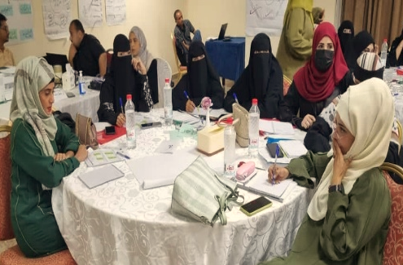
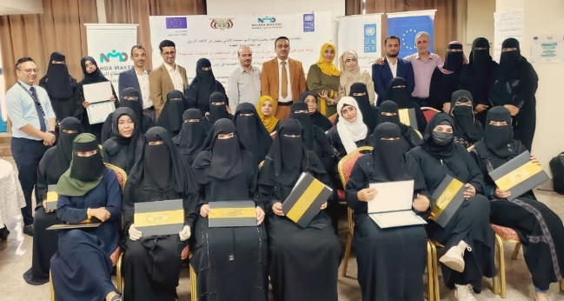
Women officials during a training supported by the SIERY Project. ©UNDP

In the DFA controlled areas, SCMCHA's overlapping authority with MoLA significantly hindered the project's implementation. SCMCHA cited concerns about perceived incompatibilities with local customs, faith, and security interests as reasons for delaying or rejecting gender-specific project activities. Despite efforts to engage MoLA, including through the Comprehensive Development Center (formerly the Gender Center) of Sana’a University, support for women's development remained limited. The Project was only able to conduct a brief institutional evaluation and provide minimal furniture support to the women's department of the ministry to bolster its resilience amidst ongoing efforts to diminish its role.

Activity 1.3.3: Platforms of local governance actors, including local authorities, are fostered, strengthened and connected to international peer support networks.

The platforms established for local governance actors that aim to strengthen inter-district coordination and cooperation for service delivery and local economic development have been established and elaborated in Activity 1.2.2.
Unfortunately, no exchange visits could be conducted during the reporting period. The Project has however, identified suitable programmes and partners and two visits are now expected to happen in early 2025 in Jordan and Egypt. The Project will pro-actively engage with the respective local authorities to make every effort to ensure that women are part of the selected delegations.

Output 2.1: Strengthened linkages/cooperation opportunities between smallholders, SMEs, private sector and MFIs involved in the value chains.

Indicators | Year 4 targets | Summary of achievements | Status
Indicator 2.1.1: Number of persons with developed capacities on business and technical skills or applied skills for income generation or employment prospects (disaggregated by sex, age) with support of the EU-funded intervention.  Baseline: 0 (2019) | Total: 3,000  Women: 900  Men: 2,100  Youth: 300  Adult: 2,700 | 3,009 have developed capacities in business and technical skills.  Women: 1,364  Men: 1,645  Youth: 849  Adult: 2,160 | Achieved
Indicator 2.1.2: Number of local SMEs and producer groups in priority sectors supported by the EU-funded intervention disaggregated by gender of owner.  Baseline: 0 (2019) | Total: 900  Women: 270  Men: 630 | 580 SMEs and 33 producer groups received support through the EU-funded intervention (total: 613)  Total SMEs: 580  Women-led SMEs: 79  Men-led SMEs: 501  Total producer groups: 33  Women-led producer groups: 33  Men-led producer groups: 0 | Partially Achieved
Indicator 2.1.3: Number of long-term jobs and employment supported/sustained by the EU (EU RF 2.12)  Baseline: 0 (2019) | Total: 6,500 jobs  Women: 1,950  Men: 4,050  Youth:500  Adult: 4,500 | 6,599 long-term jobs were supported/sustained through smallholders and SMEs.  Women: 2,089; Men: 4,510  Youth: 4,446; Adult: 2,153 | Surpassed
Indicator 2.1.4: Number of (i) smallholders and (ii) SMEs that have access to business services.  Baseline: 0 | Smallholders:800  SMEs: 400 | A total of 228 SMEs from Aden and Hadramawt have access to business services.  Aden: 65 SMEs (5 women led, 60 men led)  Hadramawt: 163 SMEs (68 women led, 95 men led) | Delayed

Following a similar three-pronged approach as under Outcome 1, the combination of capacity development (needs-based training and advisory services), planning (development of business continuity and business plans) and funding (grants) has proven successful in mitigating risks and identifying opportunities, supporting access to new markets and business expansion ultimately sustaining employment and creating additional temporary and long-term jobs.

Surveyed SMEs highlighted that through their participation in the Project they had been able to:
- Increase their revenues and profitability with sales increased by 57%, and net profits experienced a 75% increase. The value of productive assets surged by 129%, laying a solid foundation for sustained growth.
- Expand into new markets and the launch of new production lines. Firms invested an average of $7,579 in business enhancements, acquiring additional assets to bolster operations.
- Improve employment opportunities within their target market with seasonal employment showing a substantial growth of 66%.

The Project successfully stimulated financial contributions and investments by SMEs which exceeded their matching amount to the grants provided through the Project. Considering the challenging economic conditions in Yemen, this commitment demonstrates their ownership and trust that the support provided will generate returns on investment.

The endline survey conducted in July 2024 reported the impact of the support to smallholders as displayed in the table below.

Sector | # of beneficiaries | Productivity | Productivity per season | Profits & income | Yield expansion | Water consumption | Fuel consumption | Waste of crops
Horticulture | 159 | + 70% | From 3,800 kg to 6,600 kg | + 17% | +16.4% | - 46.4% | - 51% | - 41%
Dates | 50 | + 15% | From 2,708.6 kg to 3,118.5 kg | + 33.30% | + 10% | - 44.70% | - 69% | - 55%
Henna | 52 | N/A | N/A | + 63.90% | N/A | N/A | N/A | - 76.50%
Grapes | 116 | + 27% | From 197,024 kg to 425,423 kg | + 115.90% | + 23% | N/A | N/A | N/A

Activity 2.1.1: Enhanced business and technical skill development on value chain approach for medium and long terms income generation and employment prospects.
The four (4) value chain studies that had been completed in the previous reporting period are now available to the public in Arabic and English (Dates: English and Arabic; Henna: English and Arabic; Fish - Hadramawt: English and Arabic; Wheat: English and Arabic). The studies (esp. the fish value chain study for Hadramawt) have been praised for their usefulness and comprehensiveness and are used as references. The wheat value chain studies have been instrumental in shaping local food security and wheat planting strategies in the Hadramawt Valley. Local authorities have directly incorporated the findings into their planning processes. Moreover, the World Bank and the International Finance Cooperation (IFC) have recognized the value of the fish value chain studies, requesting them to inform their identification of potential investment opportunities in the fishery sector. Both the Arabian Sea and Gulf of Aden fishery and marine authorities are leveraging these studies to guide their development planning, with a specific focus on enhancing fresh fish export capabilities. Two additional studies are underway, namely for the fishery sector in Aden and for the coffee sector in Sana’a governorate, with the Aden Fish study being an additional request by authorities as a direct result of the Hadramawt study. The findings of the Aden fish value chain study were presented in a workshop to 86 representatives of MoLA, local authorities from Aden, the private sector (investors, banks, businessmen club), the Chamber of Commerce, the Aden Free Trade Zone Authority, UNDP, and SMEPS. The workshop has attracted investors' interest to contribute to existing activities such as the Fish Export Center in Aden. One of the workshop's recommendations is to conduct a raising banking awareness event for the investors (e.g., type of services and facilities provided by the banks).

In addition, the Project also finalized the following feasibilities studies: 1) Fish Farming; 2) Livestock Production; 3) Poultry (Meat); 4) Poultry (Eggs); 5) Hydroponics; 6) Animal Waste; 7) Leather Recycle, which will be publicized soon.

Linked to the selected sectors, need-based business skills capacity building was conducted for 174 smallholders and 36 SMEs from Aden, Hadramawt, Hodeidah and Sana’a (sector: vegetables, livestock, coffee). They have been trained and received business and technical advisory services in (1) technical skills on the use of modern agricultural techniques, (2) smallholders’ business skills to manage their businesses efficiently. The technical training provided focused on increasing modern input supplies depending on the sectors and crops needs.

Activity 2.1.2. Improved networks of producers (smallholders, SMEs), private sectors and microfinance institutions to strengthen the existing value chain association at district level.

A thorough assessment, conducted in collaboration with coffee farmers’ associations, local authorities, the agriculture office, coffee farmers, and project advisors, revealed that the traditional approach of providing individual grants and technical training was not optimal for the region. The primary challenge identified was the critical shortage of water, exacerbated by climate change-induced delays in the rainy season.
Recognizing that addressing water scarcity was essential for enhancing coffee production, the Project adopted a sectorial grants support approach. While farmers possessed the knowledge and capacity to purchase irrigation systems, seedlings, and fertilizers, they lacked the expertise to secure water at the right time and in sufficient quantities. Therefore, rather than issuing individual grants for equipment or supplies, resources were provided for water harvesting infrastructure as a sustainable solution to this identified problem.
15 new water tanks have been constructed and three existing tanks in the districts of Al-Haymah Al Kharijiyah and Manakhah were expanded. With an average capacity of 1,151 cubic meters, the tanks are collectively storing 20,803 cubic meters of water. This initiative benefits 197 farmers and provides irrigation for approximately 28,024 coffee trees across 208,644m². The communities contributed 22% not only demonstrating their commitment but also building their sense of ownership and ensuring sustainability in the efforts to improving coffee production and resilience in the face of challenging environmental conditions.

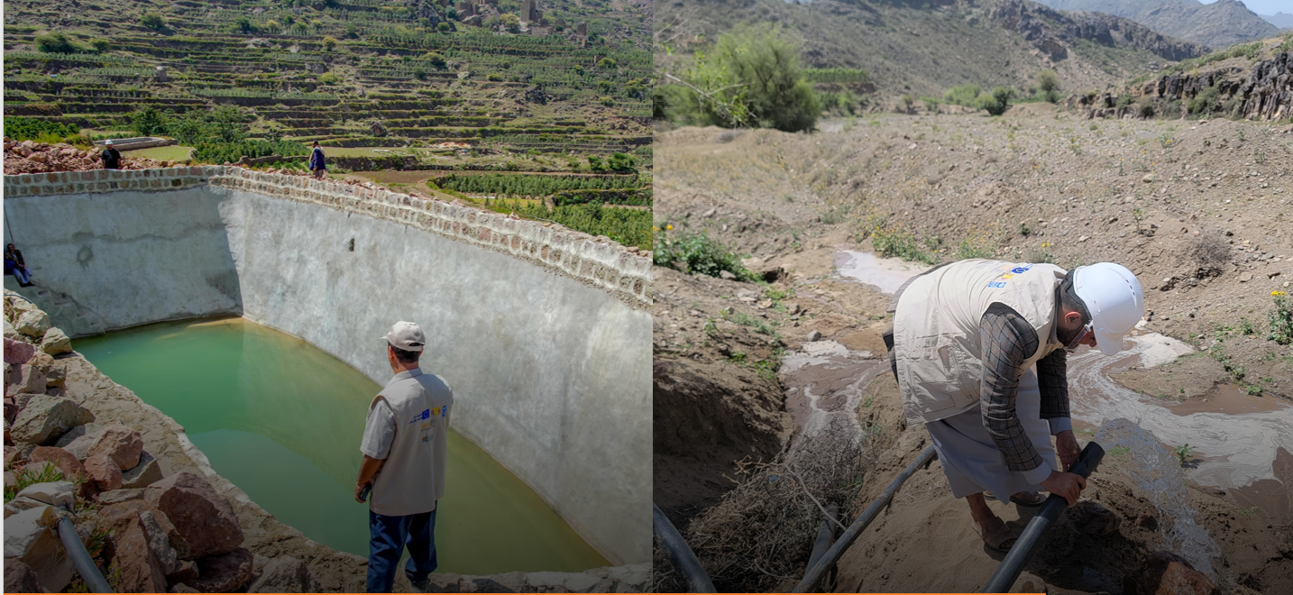
The newly rehabilitated water tank in Al-Mahjar, Al-Haymah Al-Kharijiah. ©UNDP | A construction worker installing a water pipe in Bait Abdul-Haq, Al-Haymah Al-Kharijiah. ©UNDP

The training for the smallholders resulted in the issuance of grants to 1,619 smallholders. In addition, 394 SMEs have been provided with grants for their successfully designed business plans as a result of the training. In response to the unique challenges facing coffee smallholders in Sana'a Governorate, the Project adapted its approach to include sectorial grant funding for strategic initiatives that address a specific need that is common to a whole sector.
Additional support was provided to agricultural farmers in Sana’a. The Project supported six (6) hydroponic farming units in Bani Hushaysh district. Land and demonstration plots have been prepared, equipment and supplies for hydroponics have been installed. As a result of using hydroponic systems, farmers can now produce high-quality crops, reduce the use of chemicals, and cultivate various types of crops.

The Project continued to provide technical and financial support to women businesses and associations. Acknowledging the numerous barriers to economic participation women in Yemen face, particularly in traditionally male-dominated sectors, the project directly addressed these challenges by empowering 1,364 women. This included supporting 33 women's producer groups, 79 women business owners, and creating 2,089 jobs. Through these efforts and to reach such numbers, the SIERY project aimed to increase women's participation throughout the value chain by enhancing the development of innovative, value-added products. In the Henna sector, this included Henna paste, Henna soup, and Henna shampoo. Women in the fish sector produced dry fish and canned tuna. Within the dairy sector, 900 women produced cheese and Ghee, diversifying product offerings beyond traditional dairy goods. The increase of dairy production for the 900 supported women dairy producers, a lead yogurt factory established a new production line for an organic yogurt which contains no imported milk powder, making it the first yogurt organic product in the Yemeni market. These new products not only created new jobs but also opened new markets and established a competitive advantage for women-led businesses in traditionally male-dominated sectors.

Al-Fuqom Women Association in Al-Buraiqah district in Aden governorate
Based on the findings of a needs assessment, comprehensive capacity-building support on tuna canning production was provided with specialised trainings in: (a) Food safety and hygiene standards; (b) Tuna processing techniques; (c) Business management and financial planning, and other topics.

To broaden the association's knowledge and skills, members visited the successful Al Sheher fish association in Hadramawt. This visit provided valuable insights into good practices in association management, productivity, and business orientation. During organised networking meetings, the women connected with leading fish firms in Hadhramaut which later proved instrumental in securing a favourable business deal for purchasing cans at competitive prices.

Thanks to the grant provision, the association was able to purchase a tuna production line and commenced tuna canning operations on a larger scale. Having been empowered to participate in a traditionally male-dominated sector, the women challenged gender stereotypes and expanded their economic opportunities. The association members have acquired essential skills in tuna processing, business management, packaging, labelling, branding, marketing and financial planning, enabling them to operate a successful enterprise, that is adding significant value to the local fish industry by producing high-quality tuna products.

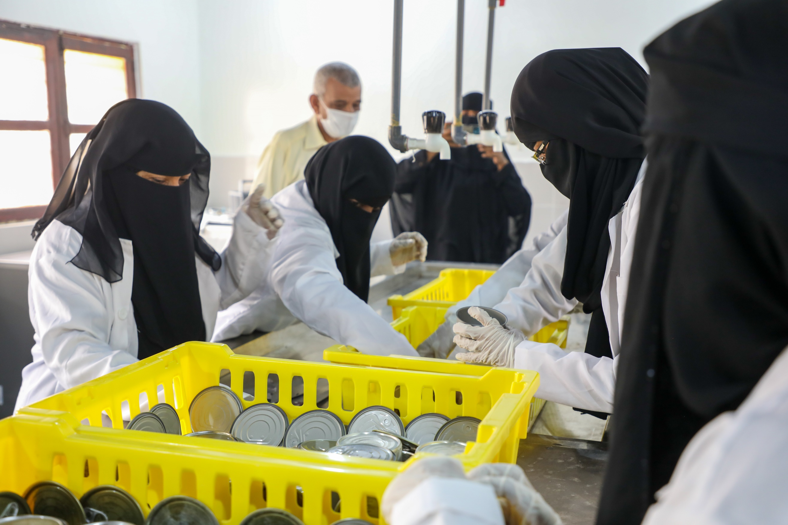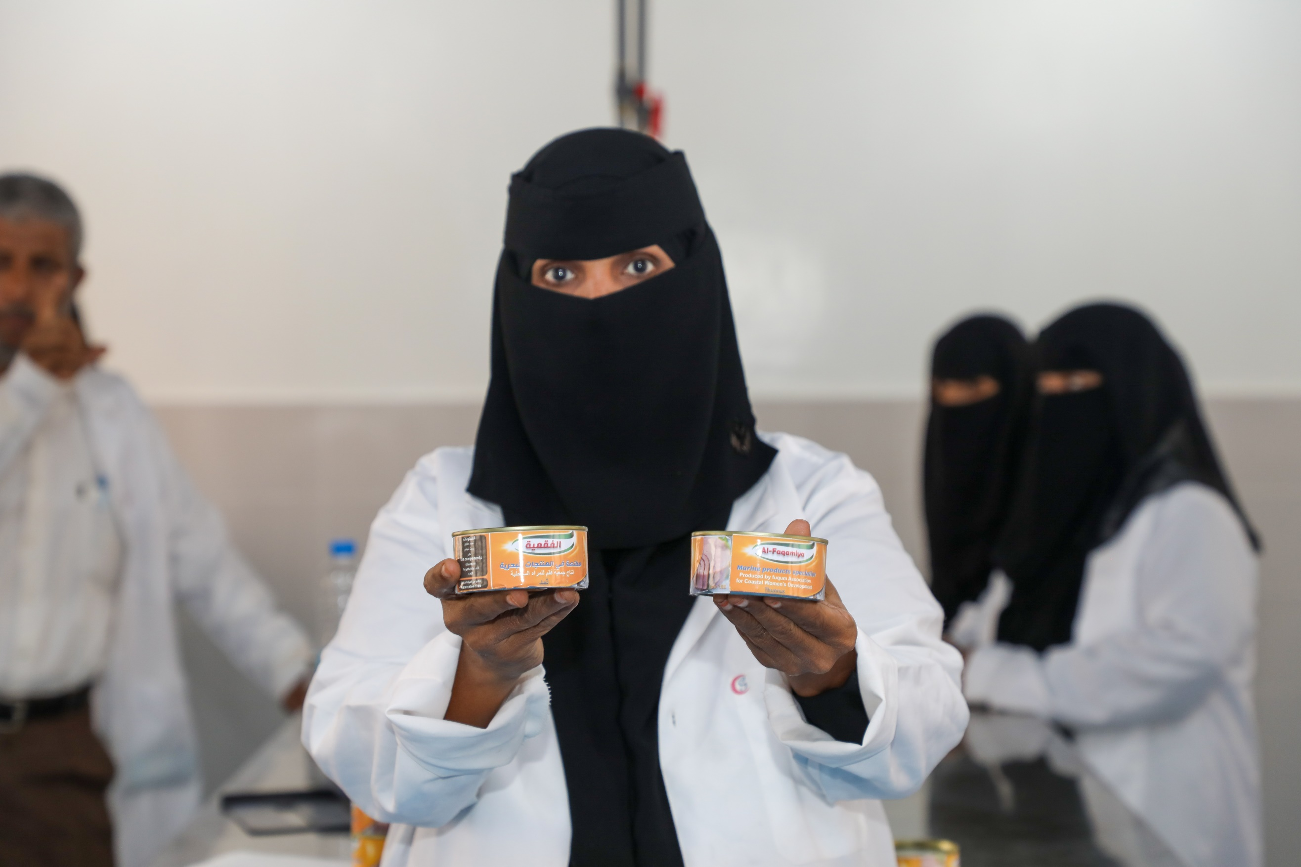
Women at a tuna canning training at Al-Fuqom Women Association.©UNDP
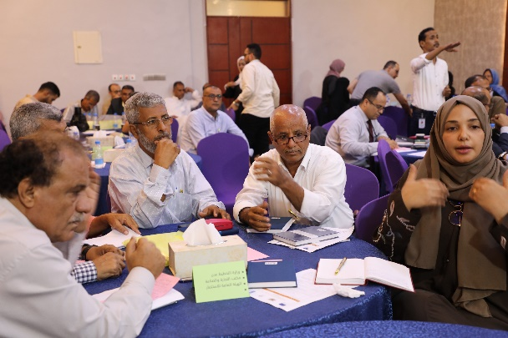
As part of its efforts to foster networking among the private sector, business associations, and local authorities, the project organized the “Value Chain and Fish Investment Opportunity Workshop” (linked with Activity 2.1.1 and Activity 2.2.1). This event provided a platform for investors, SMEs, the Chamber of Commerce (CoC), banking communities, and local authorities to exchange information, discuss challenges, and explore opportunities within the fish sector. Based on findings from the value chain study and supported by outcomes of conversations in the lead up to the event, the proposal of using the unused area around the space dedicated and allocated to the construction of the fish export Center as a “Fish Investment Zone” was adopted. Commitments resulting out of this workshop include: a) provision of all necessary facilitation and business-enabling services to encourage investment, b) financial investment of up to $20 million by four investors, c) creation of an investment fund for the fish investment zone, d) allocation of additional 200,000m² should the initial initiative take off successfully and e) the MoPIC office promising to invest $1 million in the infrastructure of the land once the Fish Export Center is constructed.
Officials discussing ways of collaboration at workshop hosted by the SIERY Project in Aden to present the findings of the fish value chain study. ©UNDP
This initiative is paving the way for a public-private partnership case in Aden and the project will be following up on the above to move it ahead as far as possible during the remaining time of implementation. The SIERY project is collaborating and coordinating with the UNDP fisheries projects, funded by the World Bank and Government of Germany, to link the fishery lead firms and investors to be part of new initiatives of larger investment zones specially in fish farming as the SIERY project produced a fish farming feasibility study which attracted potential IFC financing.

Activity 2.1.3. Enhanced business advisory support and assistance to smallholders and SMEs to improve business continuity, risk management, marketing, and expansion of business.

The Project continued to provide technical support to smallholders and SMEs in various sectors. The Project deployed over 60 Grants and Business Advisors. The field consultants provided support in the development of 124 business plans and helped to identify business needs and priorities. Before deployment to the field, the consultants were trained in various up-to-date technical skills to provide the smallholders and SMEs with targeted support.
In addition, the Project has invested substantially in allocating business advisors per target district to review business proposals or business plans developed by SMEs and Business Cooperative Associations (BCAs). As part of providing technical support on the development of business plans, the Business Advisors (BAs) also conducted several field visits to the SMEs and BAs. It is worth mentioning that the extensive field visits were undertaken during the reporting period in Aden, Hadramawt, Hodeidah, and Sana’a. The field visits were important to ensure the activities are on track and following the economic resilience approach and sustainable value chain development. For example, SIERY’s field visits have identified key challenges in engaging women in value chains and managing income-generating activities. For instance, during a visit to Hadhramaut, the team observed difficulties in reaching target numbers of women and involving them in value-added product development as SMEs within the selected economic sectors. To address this, the team implemented a new strategy for engaging women. Similarly, a field visit to Aden’s Foqom Women’s Fishery Association revealed weaknesses in managing the Tuna canning mini factory. To improve this, the project team recommended an exposure visit to Al-Sheher Fish Association to learn income and revenue management skills. Additionally, an exposure visit to a leading tuna canning factory was suggested to facilitate networking and secure wholesale can prices, supporting the association’s operations.
To address the existing business support challenges and enhance the capacity of Chambers of Commerce (CoC) to deliver services more effectively, the Project targeted seven CoCs: Aden, Mukalla (coastal Hadramawt), Seiyun (valley Hadramawt), and their respective sub-offices in Al-Sheher, Ghail Ba Wazer, Tarim, and Al-Qaten and supported them with equipment, furniture, technical skills and coaching, and, most importantly, a new system to streamline operations.
This new system links the main CoC office in Hadramawt with its rural sub-offices, enabling online registration and expediting the registration process. The implementation of this system will not only enhance the registration process for Micro, Small, and Medium Enterprises (MSMEs) but also build a robust database of the private sector in Aden and Hadramawt. Each CoC office will act as a one-stop shop for the registration process, significantly improving efficiency combining the business services of the CoCs and local authorities (LAs). At the end of the reporting period, the two CoC in Aden and Hadramawt had established such one-stop shops allowing so far, a total of 228 SMEs (73 women led and 155 men-led) accessing the business services. As these two CoC are mainly serving urban areas and SMEs, the access for smallholders has been lagging behind. The work in Marib includes a dedicated one stop shop for smallholders. However, given the described delays in the implementation of the respective activities in Marib, this will only be reflected in the next report.
Output 2.2: Increased and de-risked access to financial services for economic agents in promising value chains

Indicators | Year 4 targets | Summary of achievements | Status
Indicator 2.2.1: Number of (a) gender-sensitive market facilities and (b) related shops/stalls established with support of the EU-funded intervention.  Baseline: (a) 0; (b) 0 (2019). | (a) Market facilities: 5  (b) related shops/stalls: 80 | Tendering for 5 markets done | Delayed
Indicator 2.2.2: Number of beneficiaries (a) individuals and (b) SMEs/business associations receiving loans with the support of the EU-funded interventions. Baseline: (a) 0; (b) 0 (2019). | (a) Individuals: 300  (b) SMEs: 100 | Zero (0) loans have been paid. | Delayed

Activity 2.2.1. Construction of market facilities and infrastructures have improved access and services for smallholders, SMEs, and private sectors to improve productivity.
The designs for all five (5) public market infrastructures have been completed. This process took significantly longer than anticipated due to the quality of work submitted and the extensive review and revision process. Despite having outsourced this work, UNDP and Project Engineers had to get heavily involved. In addition, delays were experienced when unexpectedly already identified locations had to be changed and land ownership confirmation processes had to be restarted. Having resolved all matters now, the construction of the honey market in Tarim and the Date/Onion market in Al Qatan will start in September 2024, while the other projects (Fish Export Centers in Mukalla and Aden, coffee market in Manakha) have been advertised and construction is scheduled to start in October 2024. The operating manuals for the five (5) markets in addition to the fishery investment zone were finalized with the local authorities. They were submitted and the training for the markets board and management staff will start in November 2024.
The Project signed contracts with supervisory and management engineering companies for the valley markets as well as signing the contract of the UNDP supervisor engineer for the three markets in Hadhramaut.
It has to be noted that there has been a slight shift in approach from markets to export centers. One of the objectives of these markets is to significantly enhance Yemen's trade balance. By focusing on exports, the markets can generate vital foreign exchange, a cornerstone of economic stability and growth. Given that the markets’ infrastructure (building, equipment, etc.) is designed in adherence to international and regional standards, it is ensured that the products will meet the quality requirements of global markets. To streamline trade and enhance efficiency, the markets are located strategically and will serve as centralized hubs for specific products. For instance, the honey market in Hadramawt will act as a central platform for honey production and export, benefiting both Hadramawt and Shabwah. A central testing lab will ensure that exported honey meets the quality standards required by Gulf countries. Similarly, the onion and date market will facilitate the export of these agricultural products from across Yemen to Gulf countries. The two fish export centres are expected to enhance 75% of Yemen's fish exports in terms of export quality and quantity. The coordination with the SFISH project funded by the World Bank to address the standards of the Fish Export Centers within the fish landing sites. Following these standards will increase the opportunity for better income for all the value chain players starting from the fisherfolk in the fishing boat, to the landing sites, to buyers (Wholesalers/retailers) to the Fish Export Centers.
True to the SIERY approach local authorities, the private sector, and business and smallholder associations have collaborated closely to proceed to this point. As an example, for the Aden Fish Export Center, the Project secured an exceptional permit for a piece of land in the free zone in Aden, which had been unused, and its benefits suspended since 2018.

Complementing the construction of the markets is the support to legally and technically establishing the management of these markets. Operations manuals have been completed for four (4) markets along with signing the establishment law of the date and onion markets. As a next step, key market stakeholders (such as market management, shop owners, buyers, and suppliers) will be trained with the goal to institutionalize the market operations and ensure quality, efficiency and sustainability of the markets/export centers beyond the project period.

Activity 2.2.2. Improved access to microfinance services (capital and grant) for the recovery of smallholders, small and medium enterprises with good potential for job creation and income generation.
After the initial setback caused by the introduction of a new law on loans and interest rates by the DFA controlled areas in March 2023, which necessitated a redesign of the project modality and the selection of a new target area within the IRG governorates, the project had to manage another disruption to the implementation when the Responsible Party had to be replaced due to the incidents in Sana’a in June 2024.
As of now, all stakeholders in Marib have been mobilised, and for the selection of potential beneficiaries in the sesame sector the provisional lists have been received based on the established criteria. In preparation of the infrastructure of the LED modality, assessments and proposals for establishing One-Stop Shops (OSS), First Stop Shops (FSS), and Agri-Business Centers (ABC) have been reviewed. The envisaged banking partners are preparing the proposals for their respective versions of a revolving fund.

3.4 Changes introduced during the reporting period
During the reporting period, the Project implemented several changes in response to the practical realities encountered on the ground. Most of these adjustments have been detailed in the Progress Report under their respective activity headings. Below is a summary of the key changes made.
- De-prioritization of activities: In light of recent developments, and as communicated in several meetings to the EU team in Amman, the Project has deprioritized certain activities within the DFA controlled areas that were aimed at strengthening government system structures. This includes the remaining capacity development activities and the accountability package.
- Shifting to export centers: The Project is adapting the purpose of the markets from focusing solely on local customers to emphasizing regional and even global exports. This strategic shift acknowledges the potential of the selected value chain, enabling the Project to reach a broader constituency and maximize the benefits for the stakeholders engaged in the centers. For instance, in the case of the Fish Export Centers, this transition has been closely coordinated with UNDP’s fisheries projects, which are funded by the World Bank and the Government of Germany.
- Partnering with banks for the revolving fund: For the microfinance package, the Project’s collaboration will now focus exclusively on banks, rather than microfinance institutions (MFIs). This decision arose from further research indicating that MFIs possess limited cash liquidity to sustain the loan support for the SMEs and smallholders, alongside a restricted outreach in terms of number of branches. In contrast, banks have a well-established branch system and have expressed strong interest in actively contributing to the project.
- Adjustments to the HR plan: As outlined in the Amendment to the Agreement regarding the No Cost Extension (NCE), it was initially agreed that the project would gradually reduce staff during the NCE period. However, due to current circumstances (details provided in section 3.5), the Project had to adjust this plan. While the Project still anticipates a reduction in staff toward the end of the implementation phase, the original phase-out timelines have been extended by several months. These adjustments were discussed with our EU counterparts, who acknowledged them as necessary for moving forward. Importantly, these changes will not affect the overall project management budget.

3.5 Factors affecting the attainment of results and mitigation measures
During the reporting period, the project successfully completed key capacity development and collaboration activities with local authorities. Significant financial commitments were made under the L2RF-funded public service investment priorities, encompassing over 130 projects, alongside grant support for smallholders and SMEs. The focus for the remainder of the project will be on finalizing these initiatives and constructing market infrastructure in Hadramawt, Aden, and Sana’a.
However, the pace of implementation has varied. Progress has been quicker in the IRG areas while in the DFA controlled area has experienced both anticipated and unanticipated delays. The Institutional Resilience component is still ahead of the Economic Resilience component, although implementation of the latter has been improving, except for the access to microfinance. It is important to stress, however, that these are generalizations: for example, implementation is relatively straightforward in Hajjah and Ibb, but strenuous in Lahj.
The following factors have notably impacted project implementation during this period, highlighting ongoing challenges and new complexities:
- Political instability
Increased instability and insecurity have marked the reporting period. Regional tensions, particularly the conflict in Gaza and attacks in the Red Sea, have disrupted supply chains and hindered port operations. The ongoing economic conflict between IRG and DFA has complicated operational dynamics. In addition, the evolving conflict between the different political forces in the IRG areas, and with it the conflicting (institutional) centres of power, has led to unpredictable challenges. However, it has also presented the unexpected opportunity of openings for a more meaningful decentralisation, which has given the project more prominence and relevance.

- Political sensitivities
Within the above context, the topic of Accountability Standards remains sensitive, with concerns about preferential treatment hindering the discussions with both central and local authorities. While there is an understanding of the urgent need in the IRG area, the situation in the DFA controlled area is more complex. The suspension of operations for the selected Responsible Party has revealed significant resistance from authorities, leading to the de-prioritization of the related activities.

The detainment of 13 UN staff members and numerous civil society employees in June 2024 has severely restricted the operational environment. This incident, coupled with a media campaign against international organizations, has created a chilling effect on project implementation. Some of SIERY's Responsible Parties have faced direct targeted, while others have grown more hesitant in their dealings with the (local) authorities, who are imposing stricter conditions for approval and implementation. Although project activities are ongoing, these new challenges are resulting in delays, particularly concerning the realisation of the Local Resilience & Recovery Fund (L2RF) priorities.

- Financial Crisis
The liquidity challenges faced by the International/National Bank of Yemen, along with the temporary threat of SWIFT participation suspension for certain banks, triggered a significant "domino effect" on the Project's Responsible Parties. For an extended period, making transfers or cashing checks became virtually impossible. Consequently, contractors and suppliers were unable to receive payment for services rendered or goods provided. This situation not only halted the implementation of L2RF priority projects in several governorates but also adversely affected the overall financial progress of the Project.
Additionally, the Directive from the Department of Foreign Affairs (DFA) to cease payments in USD and transition to the Saudi Rial has further complicated matters. This shift has created challenges in accessing USD cash and has introduced extra costs to the project due to unfavorable exchange rates and a newly requested 2% levy by partner banks on any USD transfer. A comprehensive analysis of the financial implications for the project is currently underway and will be formally presented to the EU.
As the situation evolves, it's crucial to address these financial constraints proactively to ensure the sustainability and effectiveness of ongoing and future projects in Yemen.
- Ambivalent attitude of the DFA
Despite continuous engagement, several challenges remain resistant to mitigation measures.
- Access Issues
The project team, Responsible Parties (RPs), and Third-Party Monitoring agents have experienced inconsistent and delayed access to project sites in targeted districts. Obtaining permission for RPs to enter certain areas can take between 4 to 6 months, significantly hindering project implementation.

- Interference in Implementation
Responsible Parties encounter numerous obstacles that disrupt their activities. Despite being registered, licensed, and signatories to the required Memorandum of Understanding (MoU) with SCMCHA, they often face constraints that prevent them from executing agreed-upon activities. Additionally, they are sometimes compelled to alter their programs in ways that contradict their agreements with UNDP or are pressured to hire subcontractors or individuals selected by MoLA or SCMCHA.
- Multiple interlocutors
Determining the appropriate points of contact for engagement can be challenging. While SCMCHA is the officially designated entity that each development partner and project must collaborate with, various other groups and individuals also exert influence over permissions. This issue extends beyond Sana’a, affecting interactions at the Governorate level and sometimes even lower tiers of governance.

- Capacity limitations of Responsible Parties
The Project relies heavily on Responsible Parties for on-the-ground implementation, particularly given ongoing security and access challenges. While there have been improvements in the technical and administrative capacities of the RPs, the Project continues to invest significant resources in their development—from activity design to planning, costing, and quality assurance. The engagement of additional engineering expertise has notably enhanced the quality assurance process. However, the ongoing involvement of the National Coordinators, the Field Coordinators, the Senior Project Management Specialist, the M&E Specialist, and the Finance Officer in discussions with RPs demands considerable time and effort. The Project remains optimistic that these investments will help local actors become key partners with local authorities, ensuring the sustainability of the Project's approach beyond its timeline.

These interrelated factors create a 'perfect storm' of risks that complicate implementation and reduce flexibility in responding to challenges. As the situation evolves, the uncertainty surrounding future developments adds another layer of complexity to project management.
Overview

No | Challenges | Responses
1 | Incessant political and personnel changes at government counterparts in both regions of the country. | - Regular meetings at central level and field level to ensure that the project is abreast of any new developments that might come with new authorities as well as informing them about the project and its approach.
2 | Context instability and fluidity which remain unpredictable | - Adaptive workplan within the tolerances of the agreement. Adjustments within the plans of the RPs are made in a quick and unbureaucratic manner. Adjust and update risk logs if needed. Regular discussions with the donor.
3 | Delay in approval of permits for RPs to work in the DFA controlled area and obstacles for certain activities despite permit. | - Regular meetings with SCMCHA, UNDP, and RPs.  - Exploring alternative activities and approaches.
4 | Extensive exchanges with Local Authorities (LAs) regarding location selection and provision of official documents of these land, design, and related BoQs of planned markets by Local Authorities delayed the finalization of the market decision. | - The Field Coordinators have been working hard to coordinate and communicate with the local authorities to ascertain relevant documents (e.g. land-use permits, technical and architectural designs, and others). The overall process of liaising with local authorities takes between 3-6 months.
5 | Financial liquidity issue facing banks in Yemen has been slowing down the delivery process. | - Channelling the funds through different banks including corresponding banks.
6 | Adverse weather conditions: heavy rain and floodings in some areas (e.g., Hadramawt) disrupt construction activities and impact project progress. | - Put on-hold the construction work for 2-3 weeks, until the heavy rains stop.  - Closely monitor the forecast of weather to mitigate the damage of construction materials stored at the construction sites.

3.6 Communication and Visibility

During this reporting period, the SIERY Project developed and implemented its first strategic communications and visibility plan to raise awareness of the SIERY Project initiatives and showcase its comparative advantage, impact, and approach, all while giving ownership to Yemenis. This plan has given the team a strategic direction for a narrative aligned with the SIERY Project priorities.

Guided by this plan, SIERY has expanded its reach and engagement with target audience through posts on Facebook, Instagram, X and LinkedIn and contributed to UNDP Country Office communication initiatives, such as posts on selected International Day, and advocacy campaigns giving it more space to advocate for the project’s approach and impact.
Additionally, the SIERY Project Communications Team continues to work closely with Responsible Parties under the project to produce communications products that are in line with the project’s priorities and to identify potential communications opportunities.
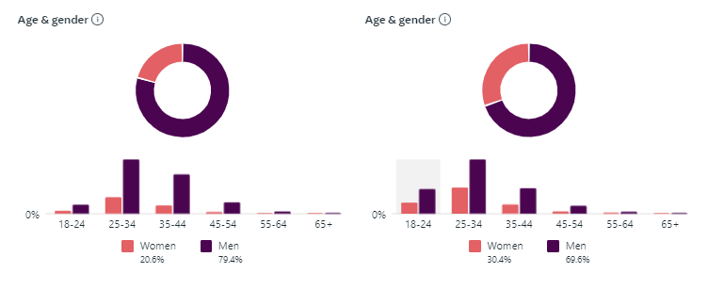
The above charts depict the background of Facebook and Instagram audiences (from left to right).

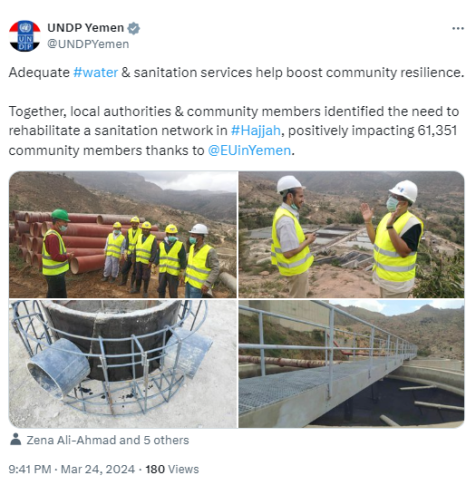  A screenshot of a UNDP Yemen X post to mark International Water Day 2024. ©UNDP | From Yemeni National Coffee Day to World Youth Skills Day, the SIERY Project marked different national and international days to showcase its work and support to stakeholders and raise awareness of the challenges facing local governance systems, educational institutions and local economic development.  International & National Days marked of note  International Coffee Day  World Bee Day  Micro-, Small and Medium-sized Enterprises Day  World Youth Skills Day  International Youth Day

In 2024, the UNDP and the European Union partnership marked its two-decade benchmark, presenting an opportunity to underscore the impact of the SIERY Project as an example of this collaboration in Yemen.  In addition to marking International Days and anniversaries, the SIERY Project ensured consistent presence and messaging on the different platforms through social media posts, videos, articles, and stories - frequently amplified and posted on Regional Bureau’s and Headquarters’ platforms, leading to wider reach and a more diverse audience. | 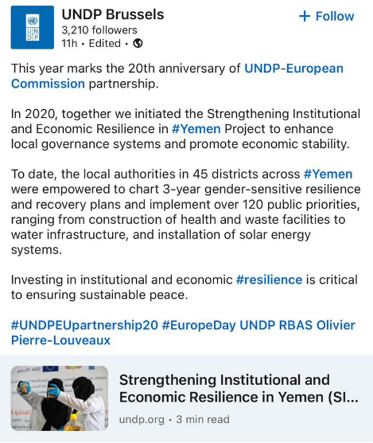  A screenshot of an X post published by UNDP Brussels to mark UNDP-EU partnership in Yemen. ©UNDP

Specific communications results:
- Eleven articles and stories were published on UNDP Yemen’s website.
- Nine videos were produced and published on different platforms.
- Over 280 social media posts have been pushed out throughout the reporting period.
- Increased recognition of traditional media outlets over local authorities’ ownership of interventions.
- Significant increase in reach and engagement across communications channels.
- Produced factsheets.
- Caps, vests, note pads and hard hats (construction helmets) have been produced including the EU logo and SIERY Project branding for the SIERY Project team.

The following are communications and visibility materials (e.g., article and human-interest stories) developed and made available for the public.
- A story on the SIERY Project’s support to local authorities in restoring educational institutions. The story was republished by UNDP HQ and on Relief Web (OCHA) Yemen and the link to the story was retweeted by UNDP HQ, UNDP at EU, and UNDP Arab States.
- A story to highlight the SIERY Project’s support to local authorities in Al-Houta to restore the fish market.
- A story to highlight the SIERY Project’s support to local authorities in Ghail Bawazir to rehabilitate and equip a surgery room at Ghail Bawazir Hospital.
- An article of the launch of the Local Economic Development package in Marib.

All communications materials were developed and published in Arabic and English to ensure that messages reach their main target audiences: the Yemeni public.

Best performing communications products
Best performing video.  Best preforming post on Facebook.  Best preforming post on Instagram. | Best preforming post on X (Twitter).  Best preforming story.  Best preforming article

The Country Office Communication and Advocacy Team continued to provide support in monitoring national and local media mentions which informs the Project Team about the general sentiment towards the SIERY Project in Yemen. The Project Team made use of this information to track and monitor the SIERY related messages circulated in Yemen. In the reporting period, more than 100 news articles by national and local media outlets have been published highlighting SIERY activities.

Human Interest Story

The promise of health in Ghail Bawazir, Yemen

Ghail Bawazir Hospital is a lifeline for community members of Ghail Bawazir, a district about forty-five kilometres north-east of Mukalla in Hadramawt Governorate, Yemen. For many years, hospital staff faced a daunting challenge: meeting the overwhelming healthcare needs of the local community with very limited resources. The hospital’s single, overstretched surgery room was a stark reflection of the broader crisis, forcing patients to make agonizing choices between seeking essential medical care and embarking on arduous journeys to other cities, a luxury few could afford or foregoing the surgery.

"We usually have seven to eight surgeries per shift. That was the hospital’s maximum capacity," says Muna, one of the hospital's anaesthesia technicians, highlighting the immense pressure on the limited resources. "The way to Mukalla is not far, but we have had medical emergencies that we needed to attend to right away, but could not due to limited capacity. A child passed away not long ago because of this," Muna shares. | 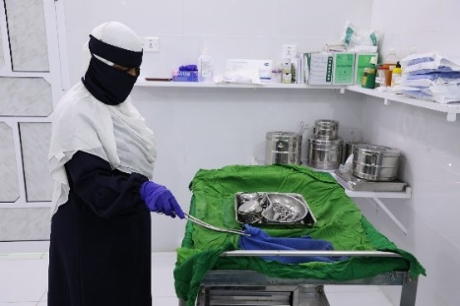  Nurse Balquees preparing for a surgical intervention on a patient at Ghail Bawazir Hospital. ©UNDP
Through the process of participatory development planning supported by the project with capacity-building initiatives, Ghail Bawazir Local Authorities and the community not only recognized the dire situation of the hospital as a major challenge to be addressed in their development plan, but selected it as one of the priorities for funding from the Local Resilience and Recovery Fund (L2RF) of the SIERY Project with focus on the rehabilitation and equipment of the hospital’s surgery room. This initiative is a testament to the growing capacity of local institutions to drive development by taking ownership of challenges and implementing locally driven solutions.
Now, with the rehabilitation of the surgery room, the hospital can handle a significantly higher number of surgeries, addressing a critical gap in healthcare access. “This initiative increased the surgery room capacity from 20 percent to 80 percent," shares Nurse Balquees, who is employed by Ghail Bawazir Hospital. She underscores the increased ability to provide essential surgeries locally, sparing patients the prohibitive costs and risks of traveling to other medical facilities. "People now can afford treatment; they no longer have to travel to get operated on," Nurse Balquees notes, her words resonating with the reassurance felt by the community.
“The funding and support provided to Ghail Bawazir Hospital has dramatically improved our healthcare services. We’ve increased our surgical capacity from one to three or four simultaneous operations, significantly enhancing patient care. This has allowed us to better serve our community. We are grateful for the local authorities’ commitment to the hospital,” states Dr. Fayez, Ghail Bawazir Hospital Director.
“The SIERY Project stands out for its collaborative approach,” explains Salem, Director of Ghail Bawazir District. “By working closely with us from the outset and empowering our community, the project fosters a strong sense of ownership. The gradual capacity building, institutional support, and inclusive engagement of various stakeholders culminated in our ability to prioritize and fund local needs. This process significantly strengthened trust among us as local authorities, civil society, and community members,” he continues.
The overhaul of the surgery room is a testament to Ghail Bawazir’s local authorities’ commitment to navigating the complexities of recovery and building community and institutional resilience. The success of this initiative has empowered the local authorities to tackle other challenges with increased confidence and has strengthened their capacity for project and financial management, and community engagement.
In Ghail Bawazir, families no longer must make impossible choices between health and financial survival. Children, like the community member recently tragically lost, can feel safer with the knowledge that they have a better chance for a future in which their basic needs can be met.

IV.CROSS-CUTTING ISSUES

4.1 Gender results
The adaptive approach to integrate Gender activities is a ‘key ingredient’ to the Project with substantial activities and ambitious Gender objectives. The achievements during the current reporting period have been highlighted under output 1.1 and 1.3. Overall, the approach has been adapted to local realities and is making use of emerging opportunities.

In the DFA controlled areas, gender remains a sensitive topic to discuss and ensuring women are actively engaged in the participatory processes is challenging. While still anecdotal, the story of a female facilitator in Hajjah Governorate who was promoted to become the Manager of the Governorate’s Women’s Development Department after she had been an active DFT member, is encouraging the project to believe that insisting on women participation does go beyond having a quota of 30 percent women representation, but indeed makes women's empowerment and participation in local development possible and very qualified women had been chosen for this important engagement.

In its initiatives for improved access to basic service delivery 54 percent of the beneficiaries were women and girls. The Project continued to promote the prioritisation of gender responsive projects in the local government plans, as reflected in the selection of priorities such as rehabilitating of additional girls' schools, maternity and childhood hospitals, vocational centres for women, and rehabilitation of the technical institutes for youth and sanitation/water improvements.

Regarding women in economic development, 37 percent of the people benefitting from the Project were women, acknowledging the importance of promoting women in economic development and gender equality. Several videos and human-interest stories highlighting this have been produced and published on UNDP Webpage and social media platforms. Refer also to Section 3.6: Communication and Visibility.

4.2 Partnership
The partnership with the EU continues to be fruitful and productive. Regular (informal) meetings - monthly or bi-monthly - are held virtually, and sometimes in person, with the EU Delegation to Yemen in Amman.
The Project maintains its good partnerships with the local authorities and chambers of commerce in the IRG governorates/districts as well as with the MoLA. The presence of the Field Coordinators remains a key for this relationship. It has enabled the Project to not only quickly pick up on changes within the governorates and potential implications for the Project, but also ensured that any issues arising, were addressed in a timely and direct manner.
The Project is fostering strong relationships with various stakeholders at all levels of government, from local districts to the central ministry. SIERY has successfully established partnerships at every level, recognizing the importance of local authorities as the foundation for training, capacity building, planning, and financing initiatives. Governorates have expressed their support for this approach, with governorate offices and MoPIC offices actively participating in these efforts. The Project's outputs are then shared with the central Ministry of Local Administration, which serves as a facilitator and connects with other relevant ministries. This partnership model, implemented with patience and wisdom, has enabled the team to build relationships with all levels of government and achieve our current progress. For the sake of sustainability, this partnership will continue at all levels and more investment will be made with MoPIC offices at governorate levels to adbot the modality of the project and continue the implementation of such work in the future once the project is done.
The partnership with the central authorities in the DFA controlled areas continues to be difficult, particularly regarding decision-making and approvals. Regular meetings are held with SCMCHA to address ongoing and new issues and seek support for UNDP and the Responsible Parties. Recent changes in the government, including the formation of a new government and the restructuring of ministries, have added another layer of complexity that requires more time to understand and navigate. Upon their request and in an attempt to foster a more conducive engagement, the project undertook a joint mission with SCMCHA to Ibb meeting with local authorities and visiting sites of selected L2RF priorities.
Within UNDP Yemen, the Project is continuing to work closely with other initiatives like the ERRY III, the Sustainable Fish project, and the Area-based Development Solution to Displacement. The goal is to ensure that these projects complement each other.
The Project and its approach are playing a key role in shaping the Area-based Development agenda of UNDP and in particular the project in Taiz which is planned to expand to Lahj and Hadramawt in the future. The strategic plans for these governorates are based on District Development Plans which the local authorities developed with the project’s support using the local participatory collaboration model. MoPIC offices are leading these Area-based Development projects and their involvement with the Project puts them at the center of this approach offering them a comparative advantage for managing these initiatives.
The Project continues with its monthly coordination meetings between all RPs and the team (also at field level through the focal point system). These meetings have proven very beneficial for all involved to not only understand the overall picture of the Project and its approach, but also to exchange lessons learned, discuss issues faced and come up with joint solutions and identification of synergies.
In the respective targeted areas, UNDP and its partners continue to organize coordination meetings inviting key stakeholders and organizations (NGOs and INGOs) working on various sectors: education, WASH, shelter, and others for synergies and complementarity.

4.3 Environmental Consideration
Environmental sustainability is very relevant to the Projects’ outputs and outcomes. The rehabilitation of basic service infrastructures, such as market facilities, schools, health facilities, is taking into consideration the provision and use of alternative and sustainable energy such as solar systems.

In addition, UNDP ensures that the partners implementing rehabilitation work put into practice Environmental & Social Safeguards including Occupational Health Safety (OHS). They are conducting Social & Environmental Screening (SES) and public consultation/ stakeholder engagement and ensure Environmental and Social Management Plan (ESMP) mitigation measures and OHS are taken into consideration in the preparation of BoQ and technical specifications.

Regarding OHS at workplace, the Project conducted awareness-raising sessions to the workers employed in rehabilitation and construction works. An example illustrated are the awareness sessions for 350 workers who carry out the construction work of the tanks and irrigation water pipes in Manakha and Al Haymah Al Kharijiyah districts of Sana’a, covering topics such as (i) the importance of wearing security and safety tools while carrying out work; (ii) the risks associated with not wearing security and safety tools while working; (iii) utilization of security and safety tools.

V. LESSONS LEARNED

Promoting local ownership is hard work, but it pays off: although a cliché in development settings, in sustained crisis contexts like Yemen, local ownership isn’t always a priority, neither for providers nor recipients of aid. However, having identified ‘sustainability’ as the corner stone of its development approach, the Project has explicitly emphasized local ownership from the beginning. It took a period of adaptation, of the Project Team as much as local counterparts, but it became clear in this reporting period that the hard work paid off: in front of donors and other UN agencies, central (MoLA) and sub-national authorities (e.g. Taiz) explicitly state that SIERY provides ‘the model for project in Yemen’, while local authorities have become increasingly assertive with donors, UN agencies, INGOs and NGOs to select priorities from the D2RPs. Local authorities are subsuming the ad-hoc project infrastructure, including the participation mechanisms with local communities and the private sector, into their own structures. Increasingly, planning structures and processes introduced by the Project, are used beyond the planning of public service delivery and local economic development, to tackle important issues such as IDP management and integration and the effects of climate change.
Process leads to good results: The Project demonstrated the effectiveness of the Local Resilience and Recovery Fund's intervention and project selection process. By involving local communities, government officials, and other stakeholders in identifying priorities and implementing projects, the Local Resilience and Recovery Fund was able to ensure that resources were allocated to projects that had the greatest impact on the community. The collaborative approach between government agencies and implementing partners also contributed to the efficient and cost-effective execution of these projects.
Continue using a ‘control hat’ when outsourcing. Due to security reasons and limited access of movement in the targeted areas, the SIERY Project works with multiple responsible parties, consultants, consulting firms, and others. In the implementation, it requires intensive coordination and communication from all those concerned parties. The Project learned that having regular meetings has proven to be effective and efficient to address challenges and constraints, exchange information, and peer-learning among the RPs. At the same time, the Project has control of what is happening in the targeted areas.
Selecting the “best champions” to implement L2RF: In Section 3.5 on factors affecting the attainment of results and mitigation measures, it has been discussed about the limited capacity of the Responsible Parties (technical, administrative, financial) in implementing the activities on the ground. SIERY learned that it needs a substantial amount of time to observe and directly assess the performance of the responsible parties that implement local government priorities/L2RF. The impressive submission of technical and financial proposals does not guarantee the performance in implementing L2RF, meeting and aligning with UNDP’s requirements and expectations. After performing an internal assessment of the performance of the RPs, the Project selected ‘the best champions’ of the Responsible Parties (RPs) to implement L2RF 2023 (six out of eight RPs continue to be awarded a contract with UNDP).

Institutionalizing the training support within the governorate and district Training and Research Centers: The Project continued to coordinate and work closely with MoLA of Aden in many aspects. One missing piece of the equation is ‘institutionalizing’ the existing Research and Training Centers. The Project learned that it is crucial to activate the role of a competent department like Research and Training Center of Hadramawt in providing training, conducting institutional analysis, and supporting local government tasks. This Center has greater control and influence over training activities due to its supervisory role and decision-making authority. This approach will improve the effectiveness and the sustainability of the training and capacity-development for local authorities of SIERY Project moving forward or beyond the lifespan of the Project.

“First Come, First Serve Principle applied by the Local Authorities”: The dynamic and fluid context in which the SIERY Project operates requires regular coordination and communication with the local authorities in the targeted areas. Even though the local priorities have been approved and agreed to be funded by UNDP, it is not a guarantee that the local authorities will not try to ‘attract’ other promising organizations or UN Agencies to fund the same local priorities. The SIERY Project acknowledged the need to speed up the process (transfer of funds, verification assessments, BoQs, etc.) and expedite the implementation of L2RF. In parallel, the progress on each step needs to be communicated to local authorities. Coordination is further tightened to understand at an early stage in the process, if other partners are involved in the same priorities.

The synergy between the Economic and Governance sector through collaboration for a meaningful development: Despite hesitation and lack of buy-in from local authorities on the SIERY model and approach, and example of meaningful collaboration between the local authorities and economic actors emerged in Bait Al-Faqih district of Hodeidah. The district manager and the agriculture manager enthusiastically engaged in value chain activities and inaugurated a Diary Product (Milk) Marketing Centre. The Project learned that more synergy between institutional and economic resilience should be put into more ‘practices’ or ‘actual implementation’ to ensure complementary and promote a greater impact, subsequently promoting a better relationship between the community and local authorities.

Time to shift from individual economic actors to sectors: Over the course of the project, and specifically during the current reporting period, it has become apparent that linking local institution and governance building is creating a huge opportunity towards economic resilience activities. In simple terms: The local authorities require capacity to start development of their respective areas and sectors. During the implementation of various L2RF projects already certain individual economic actors, including private contractors, became involved. Yet, in combination with capacitated local governance actors a more sectoral approach is becoming apparent. Examples include the linking of the fishery value chain to the export market, the sesame production and processing, honey, but also infrastructure that paves the way towards an economic development programme in energy and water provision. It is important to note that this shift is not entirely unforeseen and, in fact, was included in the original design of SIERY, but an overwhelming feeling is mounting that in order to safeguard the achieved results within local governance and improve the overall economic and social wellbeing for Yemeni people, strategic and sectoral economic development is required and must be addressed strategically in the coming period.

VI. WAY FORWARD

With regards to the remainder implementation period, the following is highlighted:
Finalization of Priorities: Completion of the implementation of the selected priorities for the 2023 L2RF, alongside the strategic priorities outlined in the multi-year District Recovery Plans.
Urbanization Initiatives: Implementation will proceed in the designated cities in the IRG areas, focusing on urbanization efforts.
Accountability Standards: The accountability package will be rolled out as planned in the IRG areas.
Adaptation in LED approach in Marib: The project has successfully established linkages and cooperation opportunities between smallholders, SMEs, the private sector, and microfinance institutions across all governorates, with the exception of Marib. There, the project has adapted the approach, and it is now linked to the microfinance work through the revolving fund which is just starting.

Completion of Markets/Export Centers: The Project will finalise the construction of five (5) markets/export centers, complemented by capacity development for key market stakeholders on market operational guidelines and Occupational Health and Safety (OHS).

Communication, visibility and advocacy: The Project will continue to enhance communication efforts by producing a range of knowledge products, culminating in the final overall project report.

Codification/consolidation of the project approach and results: To explore opportunities for replication and expansion into other regions as well as sustainability of the achievements, the Project will codify its methodology involving a thorough review of existing project documentation. The Project is starting to consolidate results and is already in discussion with the Ministry of Local Administration to see how SIERY can provide foundations for future activities whilst ensuring the solidity and sustainability of what has been achieved.

Human Resources: Effective September 2024 Mr. Maarten van Driel is the new Chief Technical Advisor/Project Manager. He succeeds Mr. Peter van de Pol, who has transitioned to a new role in UNDP Yemen.

Remaining Timeframe: Considering the significant speed that was picked up during Q2 and Q3 of 2024, the Project is confident that all objectives will be achieved by the end of the implementation period. Especially related to the Economic Resilience component, the main hurdles such as land permissions, decisions by local authorities on planning and selection, and contracting are now largely resolved, to the point that construction can go ahead at a proper pace. Barring major and unforeseen incidents or civil escalations, all remaining objectives are on track to be completed on time. The Project will continue to closely monitor all activities to ensure that course corrections are initiated if necessary. UNDP and the Project Team as well as Responsible Parties and local authorities are fully committed and are all aware and dedicated towards a solid path to the end of the project.

List of Annexes
Annex I: Financial Report and Indicative Budget Forecast (separate document)
Annex II: Implementation Plan
Annex III: Communication and visibilities of SIERY Project (separate document)

Annex II: Implementation Plan

Output 1.1: Strengthened Local authorities’ capacities to respond to community needs for services in an inclusive and accountable manner
PLANNED ACTIVITIY RESULTS | ACTIVITY | Sept – Dec. 2024 | Jan-March 2025 | April -June 2025 | July – Aug 2025
Activity Result 1.1.1: Governorate authorities have the capacities, tools and incentives to provide better technical guidance and capacity development to district authorities. | Activity Action 1.1.1.1: Update and customize training and coaching materials on public expenditure management used in previous UNDP/MoLA Projects | completed
 | Activity Action 1.1.1.2: Establish and train District Facilitation Teams
 | Activity Action 1.1.1.3: Train DFTs on gender-sensitive and youth-sensitive approaches
 | Activity Action 1.1.1.4: Develop specialized curricula resources on promoting women and youth roles in decision-making
Activity Result 1.1.2: Linkages between district authorities and communities are strengthened through the activation of representative community structures | Activity Action 1.1.2.1: Train community structures on participatory planning and service delivery monitoring | completed
 | Activity Action 1.1.2.2: Train local CSOs on Yemeni local governance system
 | Activity Action 1.1.2.3: Train local actors on conflict-sensitive local governance
Activity Result 1.1.3 District authorities are more capable of performing regular public expenditure management functions in a participatory and transparent manner | Activity Action 1.1.3.1: Conduct district-level capacity assessments by DFTs and produce District Capacity Development Plans (CDPs) | completed
 | Activity Action 1.1.3.2: Establish and train District Core Teams
 | Activity Action 1.1.3.3: Implement DCDPs (training, mentoring) by DFTs and DCTs
 | Activity Action 1.1.3.4: Strengthening data management systems (incl. ICT) in district authorities
 | Activity Action 1.1.3.5: Support (technical, financial) CSOs to pilot social accountability initiatives in selected districts on service delivery and revenue management
 | Activity Action 1.1.3.6: Provide institutional and capacity-building support to Women’s Affairs Units and women staff in district Diwans
Activity Result 1.1.4 District authorities manage their human and financial resources more efficiently and accountably | Activity Action 1.1.4.1: Conduct diagnostics on public financial management and human resource management in district authorities. | X | X
 | Activity Action 1.1.4.2: Implement District Accountability Improvement Plans (DAIPs) (coaching) |  |  | X
 | Activity Action 1.1.4.3: Assess local revenue potential |  | X | X
 | Activity Action 1.4.4: Provide training and mentoring for higher collection rate, transparency and acceptance of revenue collection, by DFTs & DCTs |  | X | X
 | Activity Action 1.1.4.5: Support (Technically / logistically) Project Units @ governorate level to enhance project technical design and costing. |  | X | X
 | Activity Action 1.1.4.6: Support governorate-based COCA branches to conduct regular audits of district accounts |  | X | X
 | Activity Action 1.1.4.7 Train local authorities on the identification of suitable funding mechanisms in the framework of local development |  | X
Output 1.2: Improved capacities of public services providers for scaling up the outreach to the most vulnerable
Activity Result 1.2.1:  Pathways for resilience and recovery of basic and social services are identified by inclusive local platforms and reflected in annual plans | Activity Action 1.2.1.1: Establish and train District Recovery Platforms (DRPs) | completed
 | Activity Action 1.2.1.2: Conduct district service delivery audits for key sector areas with the participation of DRPs
 | Activity Action 1.2.1.3: Support planning for multi-year District Resilience & Recovery Plans (D2RPs)
 | Activity Action 1.2.1.4: Provide technical support to regular district annual planning and budgeting aligned with D2RPs.
 | Activity Action 1.2.1.5. Provide leadership and communications training for women & youth, incl. members of DRPs
 | Activity Action 1.2.1.6 Coach local MoPIC units to semi-formalize and sustain the project implementation infrastructure of District Core Teams, District Facilitation Teams and District Resilience Platforms | X
 | Activity Action 1.2.1.7 Coach local authorities and local communities to develop annual workplans derived from the multi-year District Resilience & Recovery Plans | completed
Activity Result 1.2.2.:  Key sustainable development dimensions (local economic recovery, resilient urbanization) are considered by local authorities and initial actions taken in line with the SDGs | Activity Action 1.2.2.1: Raise awareness on SDG localization in 4 governorates | X
 | Activity Action 1.2.2.2 LER: Establish & mentor Collaboration Platform for Local Economic Recovery (CP4LER) between Governorate Office and Private Sector | completed
 | Activity Action 1.2.2.3: LER: Conduct diagnostics on local economy, business environment and productive sectors, including needs of MSMEs and producer groups
 | Activity Action 1.2.2.4 LER: Support CP4LER to identify and formulate LER strategy and select and propose priority projects for funding by L2RF
 | Activity Action 1.2.2.5: RU: Establish & mentor Urban Planning & Management Teams (UPMTs) | X
 | Activity Action 1.2.2.6: RU Conduct urbanization diagnostic in 3 cities | X
 | Activity Action 1.2.2.7 RU: Support UPMTs to prepare Resilient Urbanization Strategy and select and propose priority projects for funding by L2RF | X | X | X
 | Activity Action 1.2.2.8: RU: Technical support to middle-term urban planning |  | X | X
Activity Result 1.2.3: Multi-purpose local recovery supports the implementation of local priorities. | Activity Action 1.2.3.1: Establish L2RF and finalize SOPs & allocation criteria | Completed
 | Activity Action 1.2.3.2: Release funds under L2RF funding window | X | X | X
 | Activity Action 1.2.3.3 Strengthen the capacities of local authorities to coordinate donor interventions and support the authorities in pitching project ideas to potential funding entities |  | X | X
Activity Result 1.2.4: Integrated support to restoring education services in affected communities helps restore livelihoods, stability and social cohesion | Activity Action 1.2.4.1: Develop capacities on educational planning for local authorities | Completed
 | Activity Action 1.2.4.2: Provide integrated support to restoring education services in affected communities
 | Activity Action 1.2.4.3.1: Distribution of school supplies, training of school personnel on safety and risk management, and back-to-school campaigns for enrolment
 | Activity Action 1.2.4.3.2: Rehabilitate classrooms, WASH facilities, school furniture
 | Activity Action 1.2.4.4: Support school children well-being through teacher training, child protection activities, psycho-social and rehabilitative support to children with special needs
 | Activity Action 1.2.4.5: Support the education system: capacity building for local and national education stakeholders including local authorities, school management, parents’ associations and the ministry of education (MoEDU).
Output 1.3: Strengthened central-local and horizontal relations between local governance stakeholder
Activity Result 1.3.1: Regulatory and administrative measures needed to restore functional central-local relations are taken | Activity Action 1.3.1.1: Prepare in-depth diagnostic on inter-governmental relations
 | Activity Action: 1.3.1.2 Support central - local dialogue | X
 | Activity Action 1.3.1.3: Increase connectivity between local authorities and central government through e-solutions | completed
Activity Result 1.3.2: Capacities of key central authorities to support the resilience of local governance system strengthened. | Activity Action 1.3.2.1: Provide capacity development of MoLA, MoPIC & MoF + COCA |  | X | X
 | Activity Action 1.3.2.2: Support to women's affairs units in key ministries | completed
 | Activity Action 1.3.2.4: Coordination and engagement with central authorities
Activity Result 1.3.3: Platforms of local governance actors, including local authorities, are fostered, strengthened and connected to international peer support networks | Activity Action 1.3.3.1: Support and train sub-regional platforms | completed
 | Activity Action 1.3.3.3: Support South-South exchanges (2 study visits) |  | X
Output 2.1: Strengthened linkages/cooperation opportunities between smallholders, SMEs, private sector and MFIs involved in the value chain
Activity Result 2.1.1: Enhanced business and life skill development on value chain approach for medium and long terms income generation and employment prospects | Activity Action 2.1.1.1: Review and update value chain analysis of promising sectors | X
 | Activity Action 2.1.1.2: Identification of promising sectors for interventions | completed
 | Activity Action 2.1.1.3: Need based business skills capacity building for targeted individuals and SME through certified trainers, with specific promotion of women and youth, including networking | X | X | X
 | Activity Action 2.1.1.4 Coach women on processing/producing added value products, specifically branding, packaging, promotion, sales, outreach, marketing, networking, business links, etc. |  | X | X
Activity Result 2.1.2: Improved networks of producers (smallholders, SMEs), private sectors and microfinance institutions to strengthen the existing value chain association at district level. | Activity Action 2.1.2.1: Select existing business associations | X | X
 | Activity Action 2.1.2.3: Provide financial and technical support (incl. networking) to smallholders, SMEs, incl. to business associations | X | X | X
 | Activity Action 2.1.2.4: Organize networking events for smallholders, SMEs and business associations for the income generation activities. |  |  | X
 | Activity Action 2.1.2.5: Organize exposure visits for cross exchange and learning for SMEs, MFIs and private sectors |  |  | X
Activity 2.1.3 Enhanced business advisory support and assistance to smallholders and SMEs to improve business continuity, risk management, marketing and expansion of business | Activity Action 2.1.3.1 Selection of technical consultants/ business advisors in each targeted district. |  | X
 | Activity Action 2.1.3.2: Develop group of SMEs and smallholders and allocation of business advisors as per the value chain sector for mentoring, coaching and technical assistance. | X | X | X
 | Activity Action 2.1.3.3: Explore the possibility to establish Business Advisory Resource Center (BARC) | X | X | X
 | Activity Action 2.1.3.4 Coach local Chambers of Commerce to further strengthen the physical and online business services/advisory centers |  |  | X
Output 2.2: Increased and de-risked access to financial services for economic agents in promising value chains
Activity Result 2.2.1 Reconstruction of market facilities and infrastructures have improved access and services for smallholders, SMEs and private sectors to improve productivity | Activity Action 2.2.1.2: Provide capacity building for key market stakeholders (such as market management, shop owners, buyers, suppliers) on Occupational Health and Safety (OHS) to ensure mitigation of any potential hazard incidence. | X | X
 | Activity Action 2.2.1.3: Construction of identified markets through local contractors | X | X | X | X
 | Activity Action 2.2.1.4 Develop sector specific market operational guidelines and train/coach respective stakeholders | X | X
Activity Result 2.2.2 Improved access to microfinance services (loans) for the recovery of smallholders, small and medium enterprises with good potential for job creation and income generation | Activity Action 2.2.2.1: Identify microfinance institutions (MFIs) in the targeted location |  | X
 | Activity Action 2.2.2.2: Establish loan facility approach for participating MFIs | X | X
 | Activity Action 2.2.2.3: Select business proposals and provide loans through existing system to targeted individuals and SMEs |  |  | X | X
Project Management, Monitoring and Evaluations, etc. |  | X | X | X | X

Annex IV Timeline of Activities

ACTIVITIES | 2023 |  |  |  | 2024
ACTIVITIES | Sep | Oct | Nov | Dec | Jan | Feb | Mar | Apr | May | June | July | Aug
Output 1.1: Strengthened Local authorities’ capacities to respond to community needs for services in an inclusive and accountable manner
Activity Result 1.1.1:
Governorate authorities have the capacities, tools and incentives to provide better technical guidance and capacity development to district authorities.
Activity Result 1.1.2:
Linkages between district authorities and communities are strengthened through the activation of representative Community Structures
Activity Result 1.1.3:
District authorities are more capable of performing regular public expenditure management functions in a participatory and transparent manner
Activity Result 1.1.4:
District authorities manage their human and financial resources more efficiently and accountably
Output 1.2: Improved capacities of public services providers for scaling up the outreach to the most vulnerable
Activity Result 1.2.1:
Pathways for resilience and recovery of basic and social services are identified by inclusive local platforms and reflected in annual plans
Activity Result 1.2.2.:
Key sustainable development dimensions (local economic recovery, resilient urbanization) are considered by local authorities and initial actions taken in line with the SDGs
Activity Result 1.2.3:
Multi-purpose local recovery supports the implementation of local priorities.
Output 1.3: Strengthened central-local and horizontal relations between local governance stakeholder
Activity Result 1.3.1:
Regulatory and administrative measures needed to restore functional central-local relations are taken
Activity Result 1.3.2:
Capacities of key central authorities to support the resilience of local governance system strengthened.
Activity Result 1.3.3:
Platforms of local governance actors, including local authorities, are fostered, strengthened and connected to international peer support networks
Output 2.1: Strengthened linkages/cooperation opportunities between smallholders, SMEs, private sector and MFIs involved in the value chain
Activity Result 2.1.1:
Enhanced business and life skill development on value chain approach for medium and long terms income generation and employment prospects
Activity Result 2.1.2:
Improved networks of producers (smallholders and SMEs), private sectors and microfinance institutions to strengthen the existing value chain association at district level
Activity Result 2.1.3:
Enhanced business advisory support and assistance to smallholders and SMEs to improve business continuity, risk management, marketing and expansion of business
Output 2.2:Increased and de-risked access to financial services for economic agents in promising value chains
Activity Result 2.2.1
Construction of market facilities and infrastructures have improved access and services for smallholders, SMEs and private sectors to improve productivity
Activity Result 2.2.2:
Improved access to microfinance services (capital and grant) for the recovery of micro, small and medium enterprises with good potential for job creation and income generation
Project Management
Project Management, Administrative Costs, Monitoring and Evaluations

As per EU’s Info Euro rate of August 2020.
Although exact data are lacking, it is estimated that 70% of the L2RF interventions, directly or indirectly benefitted local IDPs.
Each CSO piloted one initiative targeting various public sectors (3 Cleaning Fund/Waste transports; 2 schools; 2 water and sanitation sector; 2 post offices; 1 medical service; 1 veterinary service; 1 IDP Camp Management; 1 Improvement of women's privacy at the judiciary court; 1 Public Works; 1 Environmental Sanitation Office of the Public Works Office; 1 Industry and Commerce Office; 1 Youth Support Fund; 1 traffic services; 1 Security Department).
During reporting period: 205 smallholders, 100 SMEs. Jobs and employment created:
International poverty line for Yemen: 18.3% (data 2014). This is the latest data available from the World Bank
World Bank data shows that in a Low Income (LM) country like Yemen, the average annual GNI per capita is $ 1,035.
As per amended logframe, targets are cumulative and therefore the summary of achievements in the tables is also cumulative. Figures for the reporting period are in the narrative following the tables.
The baseline data for this indicator are problematic. The 61% mentioned in the baseline is from 2019, but was in turn based upon pre-war data, the most recent one in 2014. Lack of reliable, up-to-date, baseline data, let alone disaggregated or more localized data, is a consistent problem for development Projects in Yemen. The reasons for this are: the fragmentation of central authority, with most technical capacity remaining in Sana’a in the DFA controlled area; unwillingness by the DFA to share these types of data; the significant internal population displacement; the emphasis on humanitarian data by the international community, etcetera. What we can say, however, is that over 6 million Yemenis gained improved access to basic education, energy, health, water and other public services which were either not available or with limited access, in 9 targeted governorates.
Reference point for the baseline is UNDP Yemen Integrated Results and Resource Framework updated on 1 January 2021. This indicator is reported on an annual basis, not cumulative. The result /achievement presented here is accumulative (37%).
As per amended logframe, targets are cumulative and therefore the summary of achievements in the tables is also cumulative. Figures for the reporting period are in the narrative following the tables.
Women participating in training increased their knowledge as a result of training by 39 percentage points (from 46% at the pre-test to 85% at the post-test.
Youth increased their knowledge and skills by 34 percentage points (from a 51% at the pre-test to 85% at the post-test).
21 units in the IRG area are considered fully functional, in the DFA controlled area due to sensitivities, only the “hard” support with infrastructure was allowed and it cannot be assessed how much this increased the functionality as no assessments have been permitted.
The findings from TPM of Q4 2023 revealed that 91% of community networks have established formal arrangements connecting them to local authorities. The mentioned arrangements used were: (a) joint meetings between all stakeholders played a crucial role in fostering this connection; (b) sharing data and contact information lists, having a regular and recurring meeting; (c) collaboration and coordination in joint Projects between community stakeholders and local authorities; (d) the establishment of direct communication channels with the offices and departments of local authorities.
Using data from the TPMA a series of training and capacity-building initiatives benefitted the local authorities greatly (70%), positively impacting their work (77%) TPM Q4 2023: 390 respondents were interviewed. Gender: 36% women, 64% men; Targeted Area: Al Hodeidah, Ibb, Sanaa and Taizz (DFA); Aden, Hadramawt, Lahj, Marib and Taizz (IRG); Residents or host community: 95%; IDPs: 2%; Returnees: 2%; PWDs: 1%.
community structures: Representatives of community committees, CSO, women groups, youth initiatives, private sector and influential leaders
The SIERY principle is for the priorities under the L2RF to be selected by the Local Authorities through the participatory process. When setting the targets for the indicator, the team had envisaged a similar prioritisation of education Projects as previously. This proved not to be the case with many districts prioritising non-education Projects. At the end of Project implementation, approximately 50% of the final target will be achieved.
TPMA findings: Local priorities are adequately selected by the local government and local community/CSOs/local actors during the planning process, meeting the needs of the local community and vulnerable people (94%). Improvement of access to public services has been highly perceived by community members in the targeted areas. Improved traffic flow and food supply delivery as result of ‘new’/rehabilitated public roads, implementation of the priorities has led to jobs/employments opportunities (e.g., workers/labours, suppliers/vendors, contractors) (link with Economic Resilience Component). (TPM Q4 2024: 390 respondents were interviewed. Gender: 36% females, 64% males; Targeted Area: Al Hodeidah, Ibb, Sanaa and Taizz (DFA); Aden, Hadramawt, Lahj, Marib and Taizz (IRG); Residents or host community: 95%; IDPs: 2%; Returnees: 2%; PWDs: 1%)
[1] Improvements are evidenced by the pre-and post-test evaluations showing improvements in participants' knowledge and skills. For instance, in Lahj, scores increased from 24% to 85%, showcasing the program's effectiveness in enhancing audit capabilities.
Practice exercise includes: (1) Development of Audit and Internal Review forms and preparing the report model; (2) Implementation of internal control Projects and report writing.
The main objectives of this diagnostic study are as follows: (a) to identify the current local economic situation in the target governorates by analyzing key economic indicators such as GDP, employment rates, inflation, and poverty levels; (b) to identify the current local economic opportunities available in the targeted governorates by assessing the existing businesses, sectors, and value chains; (c) evaluate the growth and development potential in key businesses and sectors by analyzing market trends, competitive advantages, and investment opportunities; (d) to identify potential obstacles and challenges to local economic growth by conducting stakeholder consultations, surveys, and data analysis; (e ) to provide recommendations and proposals to policy makers and relevant parties to support local economic growth and local development, based on the findings of the study.
Here are some media coverage (printing and local media outlets) TV channel coverage of the workshops: Aden workshop: https://youtu.be/tAG0uxoLQWY, Lahj workshop: https://youtu.be/5CRR48GJyY4, Marib workshop: https://youtu.be/hXlRyXL2wxg, https://youtu.be/tDmBeiivUsE, https://youtu.be/t5wZYJUbXs0
The minister proposed expanding the IRG's reach to include women's department representatives from all governorates, not just the five currently covered by SIERY. He argued that this would help address fragmentation and foster collaboration among these departments. The Project agreed and committed to extending its workshops to the remaining governorates.
Producer groups: dairy producers from Hodeidah (18), milk collecting center (2), 81 women-in value chain who formed groups (13).
Notable attendees included the Deputy Governor of Aden, the Head of the Gulf of Aden Fish and Marine Authority, the Head of the Free Zone Authority, the Manager of Al-Buraiqa District, the Head of the Investment Authority in Aden, the Chairman of the Aden Chamber of Commerce, and heads of various ministries’ offices in Aden, such as the Ministry of Planning, the Ministry of Agriculture and Fisheries, and the Ministry of Trade and Industry.
Al-Hudaydah: 20 firms; Aden: 329 SMEs; Sana’a: 59 firms; Hadramawt: 3 Chamber of Commerce (CoCs).
Ms Aya Al-Hamza (who later became manager of the Women's Development Office in Hajjah Governorate) and Heba Ali Yahya are the two members of the District Facilitation Teams who are outstanding and ‘stand-still’ beyond the implementation of SIERY’s capacity development program. Ms Hiba actively participated in reviewing and approving the 2022 and 2023 development plans for Hajjah City District. Additionally, she played a key role in developing a three-year (2024-2026) recovery plan for the district.
Activity 1.3.2.3 was deleted in the amendment as these events are politically not feasible and budget has been used to include the coordination activity (1.3.2.4). In UNDP’s ERP system numbering cannot be changed as it is reported against already. Therefore, the activity number is kept as 1.3.2.4 to ensure consistency with the reporting system.
Activity 1.3.3.2 was deleted as due to travel restrictions during the COVID pandemic international conference were not happening and now the Project is too far advanced to make participation meaningful
Budget will be used for actual construction of markets under 2.2.1.3 The engagement with local authorities regarding the market infrastructure component is done during the regular visits and meetings between the Project team (national coordinator and Field coordinators) and governorate/district representatives. In UNDP’s ERP system numbering cannot be changed as it is reported against already. Therefore, the subsequent activity numbers are kept to ensure consistency with the reporting system.

